

Horizon 2020 Program (2014-2020)

A computing toolkit for building efficient autonomous applications leveraging humanistic intelligence (TEACHING)

**D5.2: Preliminary use case deployment, implementation and integration report[1]†**

|  |  |
| --- | --- |
| Contractual Date of Delivery | *31/08/2021* |
| Actual Date of Delivery | *15/12/2021* |
| Deliverable Security Class | *Public* |
| Editor | *Omar VELEDAR (AVL)* |
| Contributors | *Davide Bacciu (UNIPI), Konstantinos Tserpes (HUA), Iraklis Varlamis (HUA), Massimo Coppola (CNR), Georg Macher (TUG), Juergen Dobaj (TUG), Christoph Kreuzberger (AVL), Markus Posch (AVL), Herbert Danzinger (AVL), Rosaria Potenza (M), Maria Carmela De Gennaro (M), Calogero Calandra (M), Lorenzo Giraudi (I&M), Roberta Peroglio (I&M), Sylvain Girbal (TRT), Siranush Akarmazyan (ITML)* |
| Quality Assurance | *Sylvain Girbal (TRT) and Davide Bacciu (UNIPI)* |

**The TEACHING Consortium**

|  |  |  |
| --- | --- | --- |
| University of Pisa (UNIPI) | Coordinator | Italy |
| Harokopio University of Athens (HUA) | Principal Contractor | Greece |
| Consiglio Nazionale delle Ricerche (CNR) | Principal Contractor | Italy |
| Graz University of Technology (TUG) | Principal Contractor | Austria |
| AVL List GmbH (AVL) | Principal Contractor | Austria |
| Marelli Europe S.p.A. (M) | Principal Contractor | Italy |
| Ideas & Motion (I&M) | Principal Contractor | Italy |
| Thales Research & Technology (TRT) | Principal Contractor | France |
| Information Technology for Market Leadership (ITML) | Principal Contractor | Greece |
| Infineon Technologies AG (IFAG) | Principal Contractor | Germany |

**Document Revisions & Quality Assurance**

**Internal Reviewers**

* *Reviewer 1: Sylvain Girbal, (TRT)*
* *Reviewer 2: Davide Bacciu, (UNIPI)*

**Revisions**

|  |  |  |  |
| --- | --- | --- | --- |
| **Version** | **Date** | **By** | **Overview** |
| 2.0 | 09/12/2021 | Reviewers | Final version 2.0 |
| 1.3 | 08/12/2021 | Veledar (AVL) | Final draft 2 /editor review |
| 1.2 | 07/12/2021 | Giraudi (I&M), Sardinos (HUA), De Caro (UNIPI), Lomonaco (UNIPI) | Partner contributions/review |
| 1.1 | 03/12/2021 | Veledar (AVL) | Editor response to reviewer comments |
| 1.0 | 23/09/2021 | Reviewers | Final version 1.0 |
| 0.5 | 22/09/2021 | Contributors | Final draft review |
| 0.4 | 21/09/2021 | Veledar (AVL) | Final draft/editor review |
| 0.3 | 13/09/2021 | All | Comments on draft and final contributions |
| 0.2 | 30/08/2021 | Girbal (TRT),  All (review) | First draft |
| 0.1 | 19/07/2021 | Macher (TUG),  All (review) | Reviewed ToC and initial input |
| 0.0 | 05/07/2021 | Veledar (AVL) | ToC |

**Table of Contents**

List of Tables 5

List of Figures 6

List of Abbreviations 7

Executive Summary 8

1 Introduction 9

2 The Use Cases – an overview 10

2.1 The Avionics Use Case – an overview 10

2.1.1 Tailoring the FMS application for the target TEACHING system 11

2.1.2 Tailoring the CBB application for the target TEACHING system 13

2.2 The Automotive Use Case – an overview 14

3 Dependability approaches 17

3.1 Assessment of the current safety setup 17

3.2 Cyber-security analysis on system level 21

3.2.1 Implementation of an AI-based cybersecurity application within TEACHING 21

3.3 Suggested improvements for the architecture 22

4 Technology Tailoring and Use Case Integration 23

4.1 Integration of the METrICS performance measurement environment 23

4.1.1 Using Raspberry Pi as proxies 24

4.1.2 Tailoring the METrICS driver for ARM / Linux OS 26

4.1.3 Tailoring the METrICS collector process for Linux OS 26

4.1.4 Batching and Postprocessing 27

4.1.5 Further changes for shifting to the final iMx8 target board from I&M 28

4.2 Tailoring of the THErM power measurement interface 28

4.2.1 Probing power and temperature on the iMx8 board 29

4.2.2 SoC System Control Processor (SCP) 29

4.2.3 Integration into the Cyber-Blackbox 30

4.3 Driving Simulator Integration - RT HW Platform 31

4.4 Automotive Study Design 34

5 Conclusion 38

6 References 39

# List of Tables

Table 1 - FMS real-time requirements 12

Table 2 - Raspberry Pi proxies 25

Table 3 Automotive use case scenario list 37

# List of Figures

Figure 1 Avionic use-case composed of the CBB (in blue) and the FMS (in yellow) 11

Figure 2 Flight Management System: functional overview 11

Figure 3 A vehicle convoy scenario 14

Figure 4 AD Use Case - an overview of activities 15

Figure 5 Automotive CPSoS Application 16

Figure 6 Traditional safety workflow 17

Figure 7 Simplified depiction of item definition and related systems 18

Figure 8 The most severe hazardous situations and the resulting safety goals 20

Figure 9 METrICS measurement environment 23

Figure 10 I&M carrier board & iMx8 socket-on-module 24

Figure 11 Preliminary visualisation of collected timing results 28

Figure 12 iMx8 socket-on-module 29

Figure 13 EECACC input - output variables 31

Figure 14 I&M ECU platform for integration into the driving simulator 32

Figure 15 Automotive Use Case partitioning 33

Figure 16 ECU platform integration verification 33

Figure 17 ECU back2back initial test results 34

Figure 18 Driving Automation Study Stages 34

Figure 19 Initial COntrolled Testing - Increased Cognitive Load 35

Figure 20 Creation of the Driving Environment for the Driving Scenario Building 35

Figure 21 The cut-in scenario 36

# List of Abbreviations

**AD** Autonomous Driving

**CBB** Cyber BlackBox

**CPS** Cyber Physical System

**DL** Deep Learning

**DTM** Dynamic Thermal Management

**DVFS** Dynamic Voltage and Frequency Scaling

**Dx.y** Project deliverable (x = WP number, y = deliverable order)

**EC** European Commission

**FMS** Flight Management System

**HIDS** Host-based Intrusion Detection Systems

**HR** Heart rate

**HRV** Heart rate variability

**HUMS** Health Usage and Monitoring System

**MHU** Message Handling Unit

**ML** Machine Learning

**PMC** Performance Monitor Counter

**SCP** System Control Processor

**SoC** System on Chip

**SoM** Socket on Module

**RTOS** Real Time Operating System

**WCET** Worst-Case Execution Time

**WP** Work Package

# Executive Summary

This document provides an overview of the aspects of the TEACHING project that target the demonstration of the novel technology in the controlled industrial environment at the interim stage of the project. The demonstrated use cases are cyber-black box and driving automation in the avionics and automotive domain respectively. In both cases, the focus is on human-centric control and the demonstration of related CPSoS functionalities within safety-critical systems. The key anticipated benefits are sourced from the incorporation of TEACHING Artificial Intelligence (AI) algorithms. To that degree, the current work focuses on the incorporation of the algorithms into the developed platform and their further integration into the believable, yet controlled industrial settings.

The avionics use case exploits Flight Management System (FMS), HIDS / HUMS monitoring system, and the Cyber-BlackBox (CBB) for ensuring the correct behaviour of the safety-critical software on the target hardware board. The automotive use case is considering integration of the TEACHING assets into driving simulator studies for improved understanding of human perception and hence improved control strategies for autonomous vehicles. In both cases, special attention is given to the human aspect within safety-critical environments. To that extent, the use cases adhere to the stringent dependability requirements that are a prerequisite for the integration of new components by both application domains.

# Introduction

TEACHING project’s overall objective 7 targets evaluation of the computing, adaptation and dependability functionalities of the CPSoS on safety-critical industrial applications through avionics and autonomous driving (AD) demonstration environments. These two industrial sectors are chosen to examine the potential for industrial exploitation of the technological CPSoS solutions that are being developed within projects technical WPs (WP2-WP4). The proposed CPSoS solution is leveraging novel AI algorithm enhancements, which are targeting a reduction in development loops, clarification of monitoring of development and quality processes. The solutions are also enhancing the existing safety, testability, trust and cyber-security aspects. To deliver such enhancements, the use cases target demonstration of the cooperative CPS intelligent environment with the human at its core, operation of such cooperative environment in an autonomous and trustworthy yet adaptive way and how to support these developments through dependable architectural and software adaptations [1].

The work centres on the creation of relevant data sets for algorithm training. The studies that generate the relevant data are directed by the conclusions of TEACHING D5.1, which provides the initial Use Case specification and hence sets the scene for the integration and demonstration of TEACHING technology with usage and sustainable exploitation in mind. Once mature enough for testing and optimisation, the generated algorithms and models are to be assessed in terms of their applicability for control strategies of safety-critical operations.

This deliverable provides a preliminary insight into integration activities, which are aimed at creating a suitable environment for testing the suitability of the generated algorithms for industrialisation. To that extent, the work includes adaptation and customisation of TEACHING technology (from WP2-4) to the industrial environment to be able to assess the human-centric control strategies and to increase CPSoS performance in the industrial environment. A specific outcome is represented by a set of automotive and aviation functionalities that are underpinned by specialised AI models that recognise and characterise human physiological cognitive and emotional state.

# The Use Cases – an overview

The industrial applicability of TEACHING solutions is tested through integration in a controlled industrial environment in two different domains: avionics and automotive. The target for the novel technology is to be adaptable and customisable as to offer a reusable basis for simplified portability between industrial domains. The customisable aspect of the proposed solutions is also a subject of this deliverable.

The avionics case study focuses on the safety and security aspects in the context of monitoring avionics applications. It considers autonomous detection and classification of unexpected system behaviour. The goal is to assemble an effective mitigation strategy, which results in a set of suggestions for the pilot. Those are then to be either approved or modified and acted upon by the pilot. The pilot may also choose to decline the proposed mitigation strategy if it is in their judgement that the proposed solution is not appropriate for the given situation. This interaction, between the machine and the pilot, places the human into the loop of the system as a form of improving the system safety and security monitoring.

The core of the automotive use case is built on the trend of Automated Driving (AD) for the sake of increased road safety and improved driving comfort. The key aspect is automated decision making with the user (the driver/passengers) in the centre of the system. It is the state of the vehicle occupants that is used as a basis for control strategies. The occupant state is estimated through sensing their bodily characteristics (e.g. measurement of their psychophysiological signals). The intention is to understand and model human comfort and stress and to exploit the quantification of that state for vehicle control strategies. In the simplest form, that controllability can be expressed in the choice of driving mode for the automated vehicle (e.g. normal mode versus sporty or aggressive driving style). The chosen driving scenario is that of a vehicle convoy function and motorway platooning, as described in D5.1. Special attention is paid to user perception and overall satisfaction with the system as a decisive factor for the user acceptance of the new technology.

The High-Performance Computing and Communication Infrastructure(HPC2I) developed in WP2 is an underlying part of the use cases described in this deliverable. It provides edge-cloud communication in both uses cases. In these applications, the edge client will be used to communicate with the cloud, using the Kafka protocol. The HPC2I is described in D2.2. The physical implementation is integrated into TEACHING’s computing and communication platform.

## The Avionics Use Case – an overview

The avionic use-case, presented in Section 2 of D5.1, is composed of safety and security-critical application, the **Flight Management Syste**m (FMS) and of a HIDS / HUMS monitoring system, the **Cyber-BlackBox** (CBB), that is in charge of ensuring the correct behaviour of the safety-critical software on the target hardware board. The Cyber BlackBox collects behavioural information at the hardware level thanks to dedicated **probes**, relying on performance monitoring counters and SoC-level specific probes such as temperature or power consumption probes. This collected information is then combined in an **aggregation** phase that generates traces of hardware events. These traces are sent through a **gateway** either to the external hosts on the cloud to run offline **machine learning** algorithms to fit models of the expected application behaviour, or online to the inference engine to detect anomalies and propose mitigation options, as depicted in Figure 1.

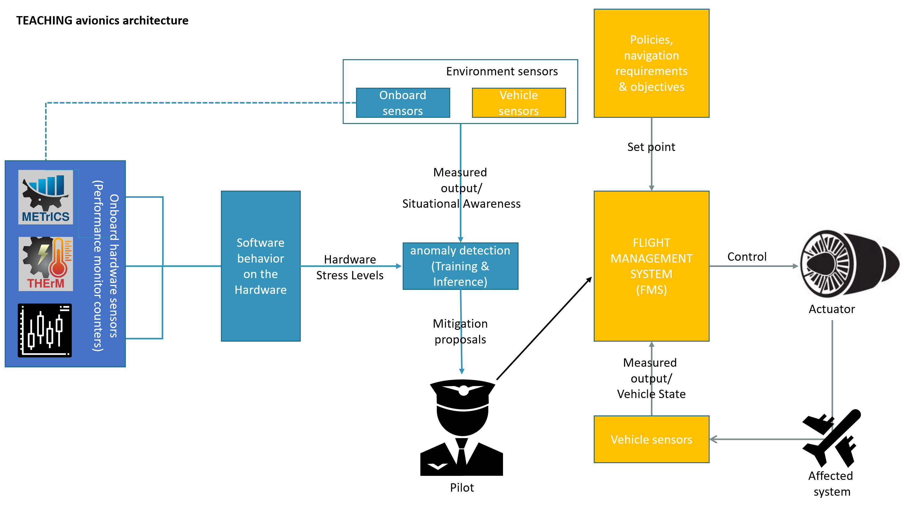

Figure 1 Avionic use-case composed of the CBB (in blue) and the FMS (in yellow)

### Tailoring the FMS application for the target TEACHING system

As detailed in Section 2 of Deliverable D5.1, the FMS application is responsible for services that allow autonomous in-flight guidance of the plane. Throughout the pre-set flight plans, starting with the airport take-off and finishing with the airport landing, the FMS is responsible for plane localisation and trajectory computation. It is FMS that enables the plane to follow the flight plan, and reaction to pilot directives.

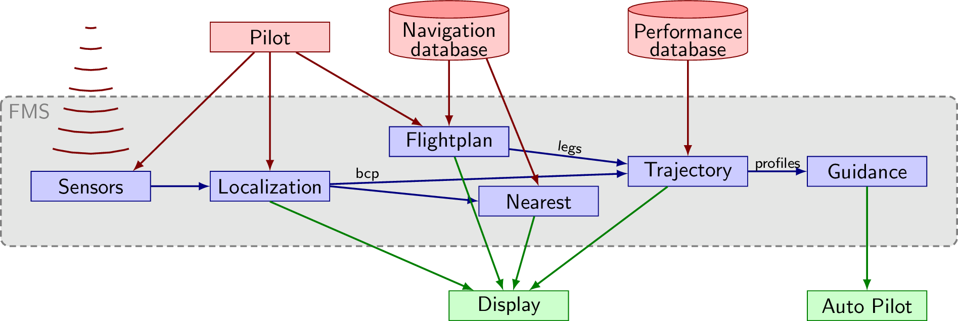

Figure 2 Flight Management System: functional overview

The FMS application is constituted by time-critical tasks that are regrouped in task groups (Sensors, Localisation, Flightplan, Trajectory, Nearest Airports and Guidance) as presented in Figure 2. The Real-time requirements of the FMS application, already presented in Section 4.1 of Deliverable D5.1 appear in Table 1.

As the FMS application is not hardware dependant, it allows an eased porting to the target ARM board. However, being time-critical, the application is expected to be run on top of a real-time operating system (RTOS). Shifting to a Linux RT operating system, which is not an RTOS introduced some specific actions to implement the required mechanisms to support periodic task execution as required above, as well as UART and socket communications.

Table 1 - FMS real-time requirements

|  |  |  |
| --- | --- | --- |
| **Task** | **Type** | **Period & Deadline** |
| SENSC1 | periodic | 200ms |
| LOCC1 | periodic | 200ms |
| LOCC2 | periodic | 5000ms |
| LOCC3 | periodic | 1600ms |
| LOCC4 | periodic | 1000ms |
| TRAJR1 | periodic | 200ms |
| TRAJR2 | periodic | 300ms |
| TRAJR3 | periodic | 300ms |
| NEARP1 | periodic | 1000ms |
| **Task** | **Type** | **Maximum activation** |
| SENSA1 | aperiodic | 2 times every 200ms |
| LOCA1 | aperiodic | 2 times every 200ms |
| LOCA2 | aperiodic | 5 times every 5000ms |
| LOCA3 | aperiodic | 5 times every 1000ms |

The FMS application is designed to ease portability to different systems, all target dependant code being grouped in a dedicated folder. The porting to ARM Cortex A53 / A72 required the following modifications:

* **Periodic scheduling support**: Hard real-time requirements presented in Table 1 depend upon real-time periodic scheduling. A classical RTOS allows us to define periodicity at task/process creation. In a Linux environment, such as our target system, the software is in charge of defining the timer to implement the periodic schedule internally to the process. To define such timers, timerfd_create & timerfd_settime system calls are used to create a Linux file descriptor to the timer, at reading to this file descriptor being blocking until the next period, or immediately with a warning in case of deadline miss.
* **UART support**: The FMS application initially used serial communication to connect to the avionic display. This display could display the aircraft position, trajectory waypoints as well as information from internal application health monitoring. In regular RTOS, the usual practice is to perform bare-metal access to the hardware UART device. In a Linux environment, this is performed by using /dev device tree and especially the TTY device files. To provide native Linux UART accesses, a regular Linux file descriptor to the TTY device is used, performing read and writes to the device after its initialisation with the proper settings.
* **Socket communication support**: So far, the FMS display has only been used to show the FMS running. It was hosted on an external host connected through the UART port. Including the FMS display as part of the CPSoS, or embedding it as part of the embedded system demands usage of alternative communication mediums. By implementing bidirectional socket communications between the FMS and its display, it is possible to build an alternative display required to have the human in the middle of the feedback loop of an AI-driven system. It also enables additional communication channels to the FMS display including some KPI from the TEACHING technology bricks. The socket communication is implemented on classical UDP Linux sockets as defined in sys/socket.h, using the connect and the send to system calls.

The previously presented modifications to the FMS application were not sufficient to guarantee a partitioned runtime behaviour. While executing the flight management application, a large number of pre-emption were observed, as well as process migration from physical cores to other physical cores by the Linux scheduler, despite the Linux RT extension.

Preventing the process/thread migration was performed by forcing the FMS application core affinity with the sched_setaffinity system call. It forces the FMS to run on a specific core, allowing us to select either a Cortex A53 core or a Cortex A72 core to run the application. However, it does not forbid the other processes running in the Linux system to run on this specific core, causing some pre-emption of the FMS application.

To solve this issue, a concept is used, similar to Jailhouse that is natively available to recent Linux kernels by setting an isolcpus kernel command line option. For instance, setting an “isolcpus=3” option for the kernel prevents its scheduler to use the fourth core to start any new process nor to migrate any process/thread to this core. Setting the affinity of a process/thread becomes the only option to run an application on this core, and specifically to ensure that no other process will run on the core dedicated to the FMS.

While the previous modification allowed the implementation of sufficient degree and space and timing isolation to run a hard real-time application, a large runtime variability is still observed despite using consistent input data that should imply a regular timing behaviour. Further investigation concludes that despite the real-time extension of the operating system being turned on, the DVFS feature remains active, resulting in frequency scaling causing period variation. Indeed, the default scaling governor is set at boot to “schedutil” so that the Linux scheduler updates the frequency scaling with the CPU workload alternating between a 600Mhz, a 900MHz and a 1200MHz frequency for the ARM Cortex A53 cores, and alternating between 600MHz, 1056MHz and 1600MHz for the ARM Cortex A72 cores. Upon turning off frequency scaling at OS level, it is possible to obtain space and timing isolation, as well as regular and reproducible timings in the FMS application, making the system suitable for hard real-time applications.

### Tailoring the CBB application for the target TEACHING system

As defined in Section 2.7 of Deliverable D5.1, the role of the cyber black-box is to ensure the correct behaviour of the FMS application on the hardware CPSoS. It corresponds to the blue parts in Figure 1. The cyber black-box is composed of:

* A set of **hardware sensors/probes** that aims at capturing behavioural information of the software with regards to hardware usage.
* An **aggregator/gateway** of all this behavioural information into traces of hardware events that could be fed up to AI algorithms, either to the network/cloud during the learning phase, or internally to the AI accelerator during the inference phase.
* A set of **AI algorithms** provided by WP4 that aims at 1) learning the expected behaviour of the software running on the hardware with regards to hardware resource usage; and 2) identify anomalies/deviation from this expected behaviour to detect potential security threats or safety issues.

The cyber black-box is developed from scratch within the TEACHING project, coupling usual monitoring frameworks with AI as an alternative to regular statistical analysis to characterise the software and the hardware. For the **hardware/sensor probes**, the initial focus was on **METrICS** (Measurement Environment for Multi-Core Time-Critical Systems) a framework presented in Deliverable D2.1 that proposes a non-intrusive and accurate runtime and shared hardware resource usage measurement. This is extended with a monitoring framework Temperature Health & Energy Monitoring (**THErM**) to gather information on power consumption and temperature from the SoC. Tailoring/integration of METrICS and THErM into the avionic use-case is presented in sections 4.1 and 4.2. They serve as sensor plugins for the cyber black-box generating behavioural traces of processor/SoC hardware events to the AI algorithms of WP4.

On the **gateway / AI algorithm side**, we focused on converging with a hardware event trace format to be used to learn the expected software behaviour to be able to detect safety/security induced deviations as anomalies with regards to this expected behaviour. These traces are initially presented in Deliverable D6.2 corresponding to the data management plan, and updated in Deliverable D2.2.

## The Automotive Use Case – an overview

As presented in Section 3 of D5.1, TEACHING’s automotive use case is designed to support the development of driving automation by integrating humans into the control loop. The integration is based on understanding, detection and modelling of human psychophysiological factors and then appropriate adaptation of the vehicle controls to align the vehicle behaviour to the environmental conditions and the human expectations. The expected benefits include increased road safety and improved driving comfort.

The specifics of the use case focus on the development of motorway platooning functionality for passenger vehicles (Figure 3), with specific attention given to the road safety aspect. The scenario is based on the lead vehicle being followed by other vehicles, all of which rely on the exact functional operation and user acceptance based on human perception of safety. Aside from the provisions of expected functionality (e.g. V2V communication and cooperation to execute coordinated control strategies), the human is specifically placed in the centre of the control loop for two reasons. Firstly, it is the measurement of human stress and comfort levels that define the technical demands from the vehicle. The additional need to interact with humans is that Level 3 and Level 4 autonomous driving require the human in the driving seat to be capable of taking over the vehicle’s controls.

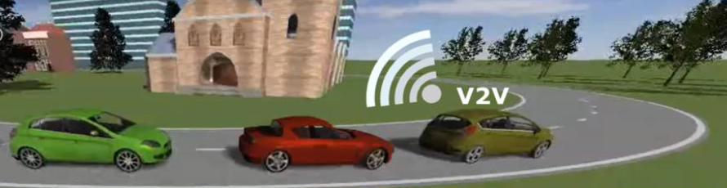

Figure 3 A vehicle convoy scenario

The conceptual set of activities related to the realisation of the automotive use case is depicted in Figure 4. The use case target is defined by the project requirements of WP1. The key aspect of the demonstration lies in the integration (described in section 4.3) of three high-level components:

* **The dependable SDF hardware platform**, which is sourced from WP2 and tailored in WP5 for the ease of integration:
  + of driving automation software - Energy-Efficient Cooperative Adaptive Cruise Control (EECACC)
  + into the driving simulator hardware setup

Aside from carrying out the runtime calculations, the platform also enables interfacing between TEACHING components required for the AD use case (e.g. sensors and actuators).

* **The physical driving simulator** (as described in section 3.4 of D5.1) with the associated driving scenarios and physical sensors for the collection of psychophysiological signals from the study participants
* **The associated SW**, which consists of:
  + The EECACC, development of which is outside the technical scope of the project, but is chosen as an appropriate application for the AD demonstration (as described in section 4.3)
  + The human modelling algorithms resulting from WP4 – the aspect which is not part of this initial integration, but is expected to feature in the final AD demonstration

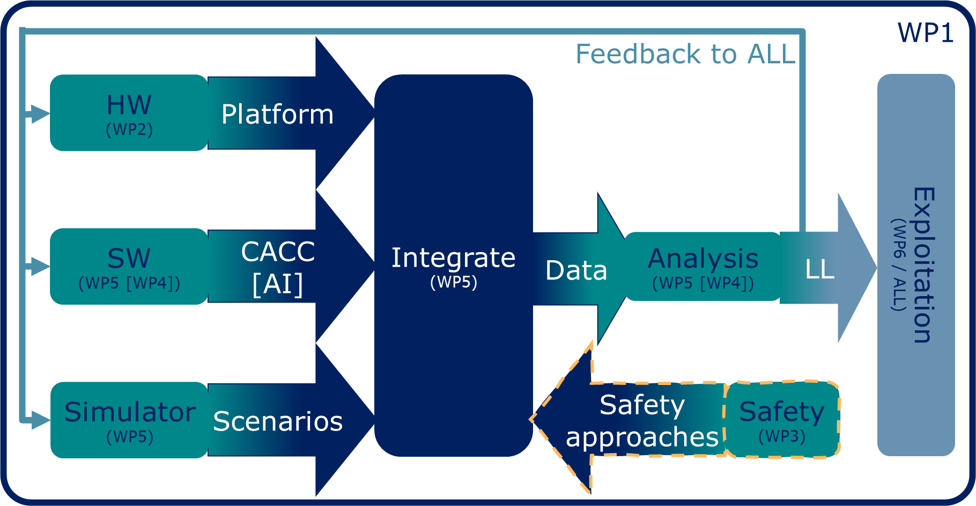

Figure 4 AD Use Case - an overview of activities

The demonstration serves a dual purpose:

* data collection as:
  + the basis for modelling of human behaviour (WP4)
  + general assessment and improvements of further simulation studies
* validation and verification of TEACHING technology bricks per project requirements of WP1.

Consequently, data analysis is performed at two levels. The first level is concerned with the dependency of AI-based approaches on the data for parameterisation (training or learning of WP4). In this case, the data quality and the selected AI architecture directly influence the quality of the function, which is later expected to generate a probability distribution to a particular input. The second level of data analysis remains within WP5 and tries to establish patterns in human behaviour at the simulator to estimate trust and potential improvement in acceptance levels of AD functionality as the result of usage of the driving simulator. To that extent, data is concerned with measuring human comfort, discomfort and overall satisfaction with the system.

The activities of WP3, concerned with the development of novel safety approaches, tap into the data analysis twofold. On one hand, WP3 tries to extract patterns relevant to ease the relationship between automotive safety and AI. On the other hand, WP3 feeds into the analysis and general Lessons Learned process as a form of feedback to improve the study and to validate the developed technology. The feedback is provided to the system integrators as well as to the WP6 as a key aspect of industrialisation. The lessons learnt are also a valuable guideline for improvements across all technical WPs.

In response to the use case requirements, the functional concept of the automotive use case is developed and is depicted at a high level in Figure 5. Rather than being an overview of associated activities (which is shown in Figure 4), this depiction reflects on the technical functions associated with the implementation of the driving automation. The concept differs from that of the avionics use case (Figure 1) in the sense that it expands the input beyond the sensor data coming from the cyber-physical components. The human measurements are also added to those provided by the vehicle and its environment. The focus of the use case study is the interpretation of the data through a suitable model of human stress and comfort, the output of which is used for training and inference. While the avionics use case at that point uses the human in the loop as the primary decision-maker, the automotive use case is directed towards automation and the human is there as a backup option to take over vehicle controls as necessary. While the yellow blocks of Figure 5 are used for demonstration of the automotive use case, these are out of TEACHING’s development scope. This section of the functional diagram takes into consideration control policies and regulatory restrictions for the current road environment (e.g. speed limit). The Decision-Making Unit (DMU) is based on an existing Energy-Efficient Cooperative Adaptive Cruise Control [2]. The DMU decisions are reflected in the vehicle control actuation, the outcome of which is monitored by vehicle sensors and fed back to the personalisation block for training and inference. This functional diagram is the key inspiration and source of requirements for the driving simulator study, which is described in section 4.4 and the intention of which is to primarily deliver training data and to be repeated for the sake of validation and verification at the later stage of the project.

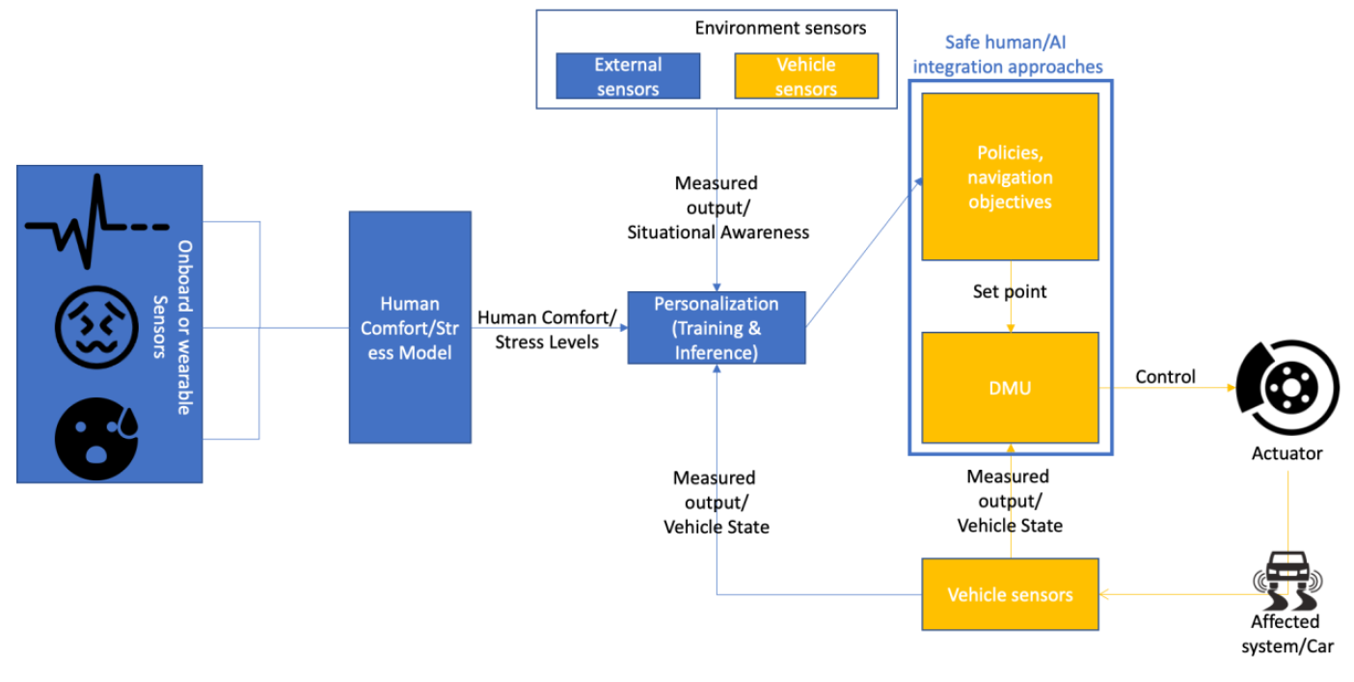

Figure 5 Automotive CPSoS Application

# Dependability approaches

The dependability approaches, most of which originate and are developed in WP3 and are described in detail in D3.2, are contributing to the practical implementation of TEACHING’s CPSoS solutions by assuring dependability through the life cycle of the proposed assets [3]. The specifics of the implementation of those approaches to TEACHING use cases are described in this chapter, which considers the current safety (section 3.1) and security (section 3.2) setups and then proposes specific architectural adaptations (section 3.3).

## Assessment of the current safety setup

AI is widely acknowledged as the most promising disruptive technology and can outperform humans in a variety of tasks by detecting patterns, infer relationships, respond, and adapt in a fast and scaled manner. Since these systems are progressively adopted in critical applications it is of paramount importance to establish trustworthy AI systems or provide measures to be dependable, i.e., resilient, robust, safe and secure.

When the AI system itself becomes responsible for generating adequate inputs for every driving situation, it must be guaranteed by the vehicle vendor (i.e., the original equipment manufacturer) that AI-generated inputs do not violate system safety. If it is not possible to verify AI safety, the AI system is deemed inappropriate for series production. Thus, safety-critical systems demand stringent compliance with safety and other related standards. The approaches for argumentations for dependability features of AI-based systems are covered by D3.2.

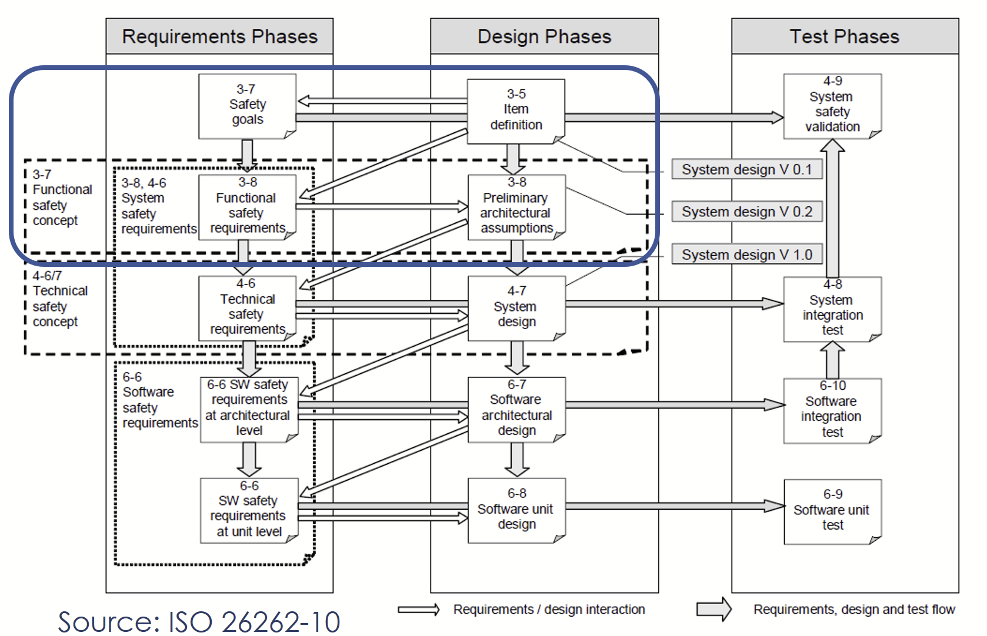

Figure 6 Traditional safety workflow

In the context of the automotive use case (Figure 5), CACC personalisation is performed through learning AI that changes the policies and parametrisation of the CACC based on passenger stress and comfort levels (i.e. user perception of driving). The concept of a policy-based decision integration pattern is applied (see D3.2 for more details). In this concept, the AI-based system is responsible for observing and analysing specific tasks or components (in this case the passenger and its perceived comfort) and recommends actions that can be translated into a finite set of policies and objectives. These policies and objectives are then used to influence the setpoint generation of the safety-critical system (CACC). Therefore, the traditional safety workflow and conventional safety analysis techniques, as described in this section and depicted in Figure 6, can be applied.

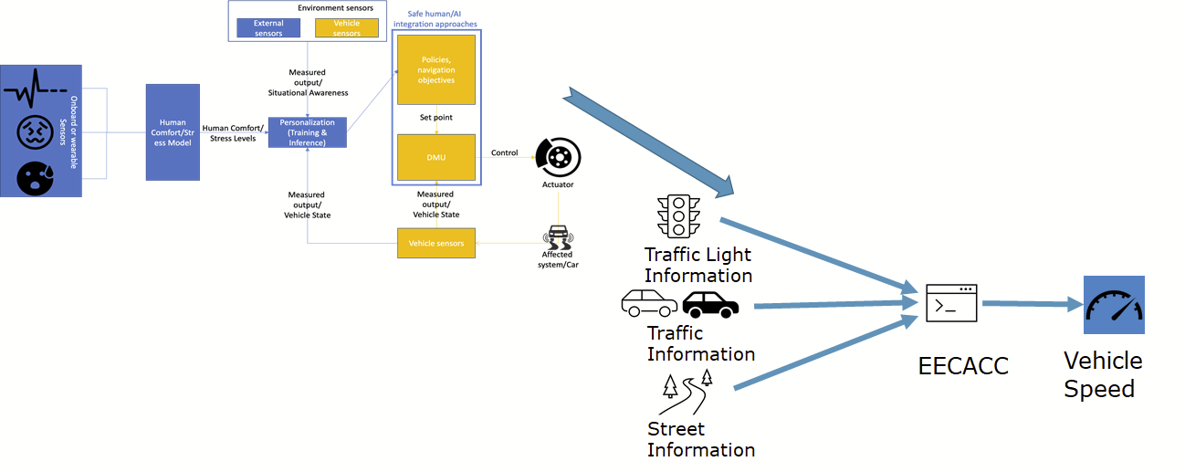

Figure 7 Simplified depiction of item definition and related systems

The hazard and risk analysis (HARA) of the high-level item design (Figure 7) results in assigning Automotive Safety Integrity Levels (ASILs) to hazardous events and the formulation of safety goals. To that aim, possible hazards are identified and the worst possible situations in which these hazards may occur are combined with hazardous situations. These hazardous situations are evaluated for their involved severity of the event, exposure to the situation, and controllability of the situation by the driver. For each safety-critical (ASIL > QM) event a high-level safety requirement (safety goal) is assigned to prevent unreasonable risks. These safety goals must be broken down to system safety requirements during the development of the system.

The outcomes of the HARA have been conducted via expert workshops and in alignment with analyses conducted by Stolte et al [4]. Therefore, the most severe hazardous situations and their resulting safety goals, as depicted in Figure 8, are related to:

* Unintended or not permitted changes of operation mode set point
* Intended and permitted changes of operation mode set point not executed
* Unsupported human set point intervention
* Alternating changes of operation mode set points

The four most crucial safety goals linked to the item are:

* SG1 prevent from unintended or not permitted operation mode change (ASIL D)
* SG2 support human intervention (ASIL D)
* SG3 intended and permitted operation mode must be ensured (ASIL D)
* SG4 prevent from alternating operation mode set point changes (ASIL D)

During the further development of the system, the impact of the components of the item definition related to the safety goals is analysed. Then the safety goals are broken down to system safety requirements and linked to these components of the item. In such a manner, an adequate level of safety measures, diagnostic coverages, and component quality, as well as, safety strategies to implement the system accordingly, is established. The activities of the functional safety concept (FSC) are described in ISO 26262, part3. The objective of the FSC is to derive functional safety requirements from the HARA safety goals. The second objective of the functional safety concept is the allocation of the safety requirements to (a) the E/E-Systems and E/E-elements of the item, (b) other technologies within the item, or (c) to external measures.

In the context of the CACC and AI-based human monitoring, an appropriate decomposition of safety constraints has been established. As it is expected that also AI-enhanced systems being based on components, which are originally designed for human interaction, it is most likely that the effort for redesign and re-assessment of these components is kept as low as possible.

Therefore, also for the CACC, safety constraints will be only put on the CACC and decomposition of the CACC (ASIL D) and AI-based control (QM) is also the likeliest implementation for this use case in series production.

This results in the following additional considerations that need to be covered with the highest ASIL quality measures for AI-based adaptation and reduced interaction by driver:

* Human intervention (override) must be supported
* Safe / limp-home mode must be supported in any driving situation
* Changes between set points must not violate vehicle safety and stability
* The alternation between set points must be limited to avoid vehicle instability

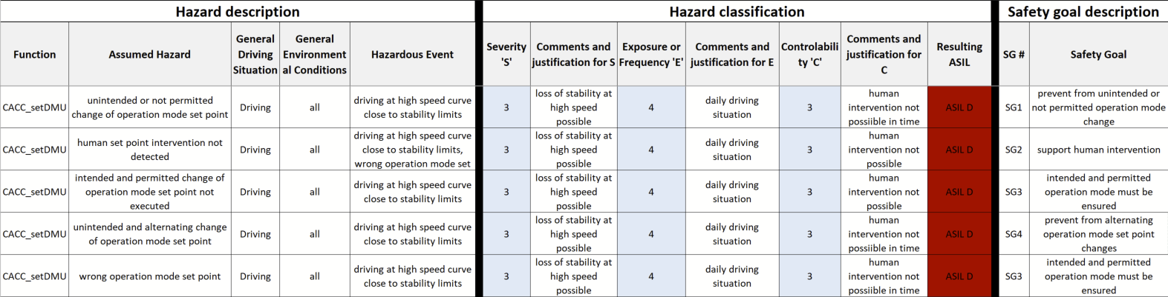

Figure 8 The most severe hazardous situations and the resulting safety goals

## Cyber-security analysis on system level

### Implementation of an AI-based cybersecurity application within TEACHING

As CPSoS comprise multiple components responsible for real-time computations, physical processes, and network connectivity operations, their complexity and their interactions with the physical and the cyber world give rise to cybersecurity concerns since security, protection and trust are crucial requirements for dependable and safety-critical systems. Cybersecurity in CPSoS incorporates traditional principles such as confidentiality, integrity and availability, but additional challenges emerge due to the nature of these systems and the application domain specifics. Some of the challenges related to CPSoS requirements are real-time response, high availability, resource constraints at the edge devices (e.g., limited memory and processing capacity), managing proprietary protocols, lack of encryption and authentication by design, and finally a distributed field of operations. In this context, conventional intrusion detection systems appear less reliable, especially when security compromises are novel and have not been defined yet in a deterministic way. A conventional intrusion system looks for abnormal patterns with a rule-based approach, e.g., by allowing only certain communication protocols, or limiting communication between specific nodes in the system. These methods require regular updates, a process that is slow, tedious, and error-prone. Signature-based malware detection looks for specific malware signatures in a database to detect malicious code. However, such an approach is not effective for zero-day exploits, i.e., attacks that have not been encountered before.

AI fosters security in CPSoS by providing proactive security mechanisms to detect both well-known attack patterns, but also predict unknown ones. In TEACHING, AI-powered components can provide solutions for monitoring and applying dependability constraints, e.g., an anomaly detection module can be used to monitor network traffic, detect abnormal patterns, and estimate their critical status to inform a human or decide action on each own. In that sense, the AI component can be thought of as a guard that monitors other components and their communications, analyses their behaviour, makes inferences, and takes actions to attain the dependability of the system – either with human feedback or based on own policies or models. Data-driven Machine Learning (ML) or Deep Learning (DL) algorithms used for anomaly detection are not restricted by specific rules or malware signatures, and thus, they can potentially generalise better since they are essentially built to learn expressive representations of complex data and model nonlinear relationships within the data domain, instead of applying specific rules. In other words, an AI-based solution at inference will look for patterns of malicious events, instead of hard-coded instances. In domains where the task and the data dimensionality are of high complexity, ML/DL algorithms can offer a scalable solution.

The TEACHING DL algorithm implementation is a Long Short-Term Memory Autoencoder (LSTM-AE) [5]. The model follows from the conceptual paradigm of learning feature representations of normality [6] to detect anomalies. Essentially, this paradigm couples feature learning and anomaly scoring in a unified model. This is achieved by learning representations, which are forced to capture underlying regularities from normal data using a generic objective function. The anomaly scoring is then calibrated based on the objective error of the normal representation, and values exceeding it are indicators of anomalies. The generic nature of the algorithm makes it suitable for other applications besides cyber threat detection within the TEACHING framework. For example, anomaly detection can be applied to human biometrics data, or resources consumption measurements, runtimes, and other unlabelled time-series data.

## Suggested improvements for the architecture

Dependability engineering aims at providing a convincing and explicit argumentation that the system under development has achieved an appropriate level of maturity. Although several approaches exist for addressing different dependability features (e.g. safety, security, reliability) while developing automotive systems, many of these methods are often performed independently and cross-dependencies and mutual impacts are often not considered. Concepts for cooperative dependability analysis and dependability engineering approaches are scarcely available.

To address this problem, a systematic pattern-based approach that interlinks safety and security patterns and provides guidance concerning selection and combination of system engineering needs to be considered. Safety and security aspects must be considered in a holistic way due to tighter interactions between safety and security in automotive CPS. Safety & security co-analysis refers to methods and techniques that can be used to identify safety hazards and security threats in a joint approach and include activities in the early stage of the development life cycle, e.g. in the requirements engineering as well as the design phase. Safety & security co-engineering refers to engineering activities that consider both safety and security and their interactions in the development life cycle like trade-off analysis or shared testing, verification and validation.

As such, the following steps are being taken

* Performing co-analysis for safety and security aspects for identification of affected elements regarding new failure modes (safety) or new vulnerabilities (security).
* Harmonisation of approaches: Joint engineering teams need to elaborate and define safety and security measures based on available patterns and use case needs. To successfully harmonise possible side-effects between safety and security, measures need to be considered and possible misuse cases elaborated.
  + All safety and security requirements shall be covered without contradiction ("freedom of interference").
  + Safety and security concepts shall be available and possible to elaborate independently.
  + Joint prioritisation which aspect is more relevant and a trade-off between safety and security measures have to be chosen.
* The final activity of the approach is the argumentation and establishment of dependability case reporting. In that task, the safe and secure concepts are available and the rationale will be collected to compile the final safe and secure argument of the elaborated concept, that provides a piece to the Assurance Case.

# Technology Tailoring and Use Case Integration

TEACHING works towards delivering an application-specific environment that is portable across industrial domains and that enables cooperation between humans and cybernetic entities, where the latter delivers dependable automated controls, which are driven by the implicit human feedback from reactions to CPSoS operation. To that extent, the use cases focus on tailoring the TEACHING technology (from WP2-4) for adequate edge computing deployment. The current state of the tailoring, as well as the study design, are explained in this chapter.

## Integration of the METrICS performance measurement environment

Section 5.4 of D2.1 introduces **METrICS, a Measurement Environment for Multi-Core Time-Critical Systems**, a framework depicted in Figure 9 proposing accurate runtime and resource usage measurement with a negligible impact on timing behaviour.

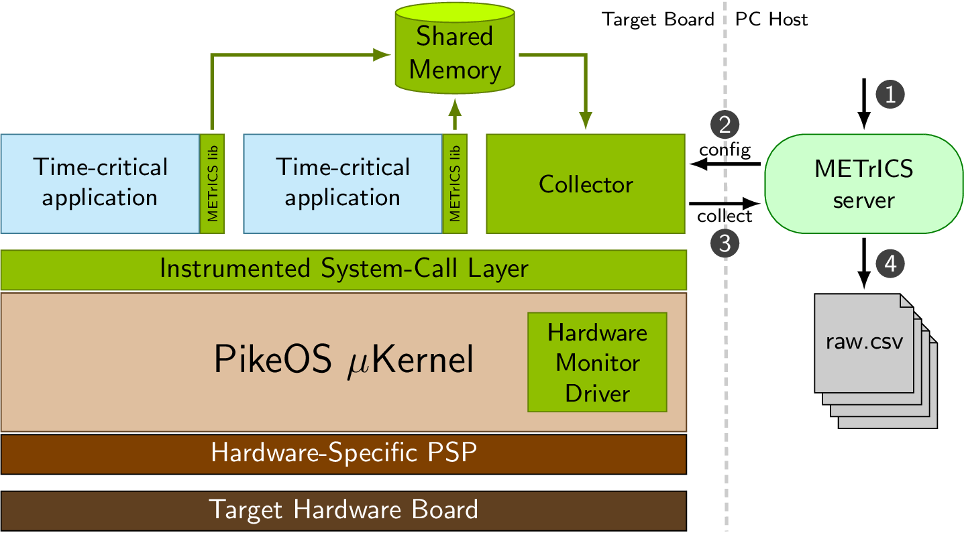

Figure 9 METrICS measurement environment

Software-related METrICS components include the **METrICS library** which allows insertion of measurement probes in the safety-critical software, the **syscall instrumentation** layer provides a way to automatically instrument each operating system call and the **collector process** that defines a shared memory space to collect measurements and configures specific measurement scenarios.

Hardware-related METrICS components include the **hardware monitor kernel driver** that provides the supervisor-level privilege necessary to access the hardware performance monitor counters (PMC) and, to some extent, the **collector process** that transfers the collected profiling information to an external Linux host.

The METrICS measurement environment is integrated into I&M’s Yocto-based iMx8 board, which is described in detail in D5.1. The process involves mostly:

* **METrICS driver**: To implement hardware-dependent accesses to the timebase (number of cycles elapsed since boot) and the PMCs (performance monitor counters counting hardware events such as the number of cache misses). This is a very low-level implementation performed in assembly code relying on the detailed core documentation. Some of the exploited assembly level instructions require privilege escalation, hence dictating implementation of this component to be done in a Linux kernel driver, with some adherence to the operating system.
* **METrICS collector process**: The collector process is meant to run alongside the critical application while minimising timing interference. With RTOS, the operating is in charge of minimising co-running occurrences between the critical application and the collector. Whereas the driver is very hardware dependant, the collector process is very operating system dependant, dealing with shared process memories, semaphores, and inter-process communication.
* **METrICS system call layer**: The system call layer is capturing the call to the operating system, inducing a pre-emption of the application for the OS to provide a specific service such as file descriptor manipulation, process and thread handling, or inter-process communication. Due to our reliance on shared inter-process memory to collect monitoring data, particular care of the additional costs in terms of timing requires analysis during the collection of this information.

### Using Raspberry Pi as proxies

As the target I&M board was still in development at the start of the TEACHING project, two different boards were identified to act as a target board, each using a different System-on-Module (SoM) of a single carrier board provided by I&M: an iMx8 SoM and an ultrascale+ SoM. For the avionic use-case, the iMx8 version was targeted to act as the embedded avionics hardware to run the Flight Management System and the METrICS performance monitoring environment. The block diagram of this hardware architecture is presented in Figure 12:

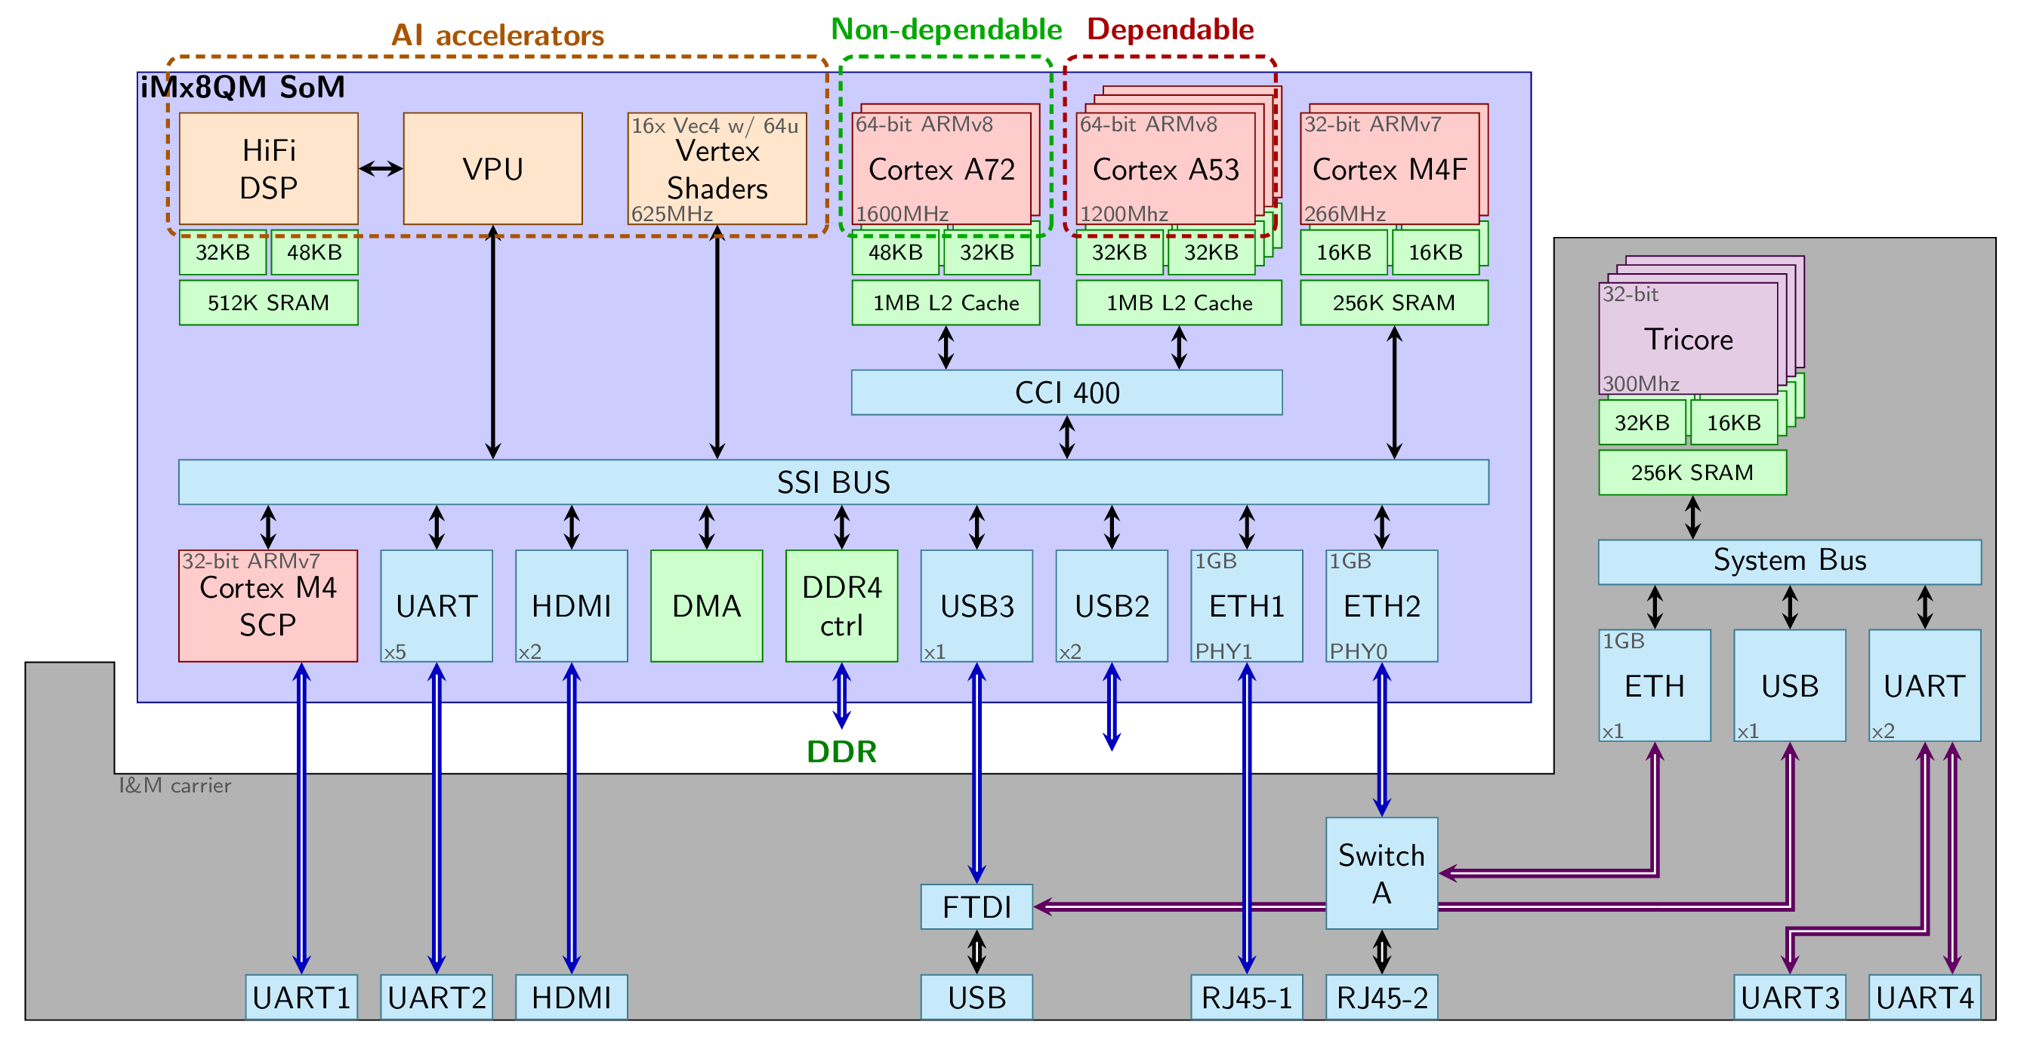

Figure 10 I&M carrier board & iMx8 socket-on-module

The iMx8 SoM includes a cluster of 4 ARM Cortex A53 predictable cores that are fitting well the performance requirements of the FMS application and the sensor part of the CBB, and a cluster of Cortex A72 cores that can run the inference part of the CBB. The latter can also use some specific hardware AI accelerators.

As a proxy to these specific ARM cores, while waiting for the hardware board to be available, Raspberry Pi based proxies were used to perform the early implementation/integration. The Raspberry Pi3B embeds a 4-core 64-bit Cortex A53 core running at 1.2GHz, while the Raspberry Pi 4 embeds a 4-core 64-bit Cortex A72 core running at 1.5GHz. They both run the RaspiOS operating system (previously raspbian) based on the Debian Linux distribution.

Table 2 - Raspberry Pi proxies

|  |  |  |
| --- | --- | --- |
| Photo |  |  |
| Processor | Broadcom BCM2837B0 Quad core Cortex-A53 @ 1.4GHz | Broadcom BCM2711 Quad core Cortex-A72 @ 1.5GHz |
| RAM memory | 1GB | 4GB |
| GPU | VideoCore IV @ 250-400MHz | VideoCore VI @ 500Mhz |
| Ethernet | 300MHz | 1000Mhz |
| Wifi | 802.11n | 802.11ac |
| Bluetooth | 4.1 | 5.0 |
| OS | RaspiOS Linux 64bit | RaspiOS Linux 64bit |

The integration started by porting the FMS application, which is planned for monitoring with METrICS to the Linux-based Raspberry Pi 3 board[2]. Beyond the hardware-induced tailoring of the application already presented in Section 2.1.1, most of the modifications were due to the shifting from a hard RTOS operating system to a Linux operating system while still guaranteeing a real-time behaviour for the tasks presented in Table 1.

The process relied on sys/timerfd.h system calls that were integrated into Linux since kernel 2.6.24. It allows the association of a file descriptor with timer events: a call to timerfd_create allows the creation of such a file descriptor and to associate it with a clock monotonic timer. Then, timerfd_settime enables the provision of the desired expiration time corresponding to the task period. A process that now reads on a timer file descriptor is blocked if the timer does not expire, mimicking the wait for the next activation period. Furthermore, the return value of the read system call lets counting the number of the deadline misses to assess for the proper real-time behaviour.

The first implementation of METrICS targeted the PowerPC E6500 hardware architecture and the PikeOS 4.0 operating system. While considering a port to ARM-v8 architecture within the SAFURE project, the METrICS was already refactored so that the hardware-dependant part is clearly identifiable and easily interchangeable. Ports exist for PowerPC, ARM-v8 and RTEMS hardware architectures, these versions were still running on top of PikeOS.

Some TEACHING activities were dedicated to adding multi-OS support to METrICS in addition to the multi-hardware support. The specific changes for the integration of METrICS to the Raspberry Pi boards are presented in the following subsections.

### Tailoring the METrICS driver for ARM / Linux OS

As already stated, the role of the METrICS driver is to provide low-level access to the timebase and the performance monitor counters (PMCs). Beyond the registers corresponding to the PMC counters themselves, some additional configuration registers are provided by the ISA to set up which events each counter should monitor, to start or reset the counters etc. Accessing or configuring such hardware related features requires privileged access, and therefore can only be performed as a driver for the Linux operating system so that it can run in the kernel space.

Accessing caller data or providing data from within driver requires dedicated functions provided by the kernel (copy_from_user, and copy_to_user) allowing to copy data from one memory space to the other as they are not sharing the same virtual memory translation memory map.

The external interface of the driver to the user space is performed through ioctl calls to the /dev/metrics device driver. The following ioctl-based services are provided:

* **CHECK_PROC**: returns SoC and CPU versions
* **INIT_PMCS**: Enable the usage of PMC registers, making them accessible to the user space to avoid system calls to read performance counters. Configuration registers still require kernel space accesses.
* **CONFIG_PMC**: Select which hardware event a particular PMC should count using the configuration registers, and reset the counter value to 0. Does not actually start the counter.
* **START_PMCS**: enable, reset and starts all the PMC counters, each counting the event specified with CONFIG_PMC.
* **STOP_PMCS**: stop all the PMC counters, actually freezing their values.
* **GET_PMCS**: Returns all the 6 values tracked by the PMC counters. Less efficient than user-space access to the counter, but necessary if counters are not accessible this way for security reasons.

### Tailoring the METrICS collector process for Linux OS

The purpose of the METrICS collector process is in charge of configuring the monitoring of the critical FMS application, as well as collecting the traces of hardware events that, during the learning phase, will serve as input to capture the nominal behaviour of the critical application, and, during the inference phase, will be used to detect deviation from the expected behaviour.

To do so, this collector process is in charge of:

* Configuring the 6 PMC counters to a set of predefined configurations to cover the whole set of measurable hardware events, such as the memory path subset focusing on data cache and memory activity, the application characterisation subset focusing on the different instruction types, the speculative characterisation instruction subset focusing on speculative instructions, the flow characterisation subset focusing on the instruction cache and the branch instructions, the TLB subset focusing on page faults and virtual memory translation.   
  Setting up such configurations is the only hardware-dependent task while porting METrICS to the Cortex A53 and the Cortex A72 cores. Both these cores share some hardware events whereas some are specific to one of these cores.   
  This activity relies on the METrICS driver first performing an INIT_PMCS ioctl call to /dev/metrics to make the PMC available, then using the CONFIG-PMC ioctl call to setup the hardware event counted by each PMC. It also requires us to use affinity-forced pthread to set the PMCs on each target core.
* Setting up the shared memory that will serve to store the per-core collection of hardware events. This collection is accessed from both, the probes inserted into the time-critical application (FMS) and from the collector process to generate the trace files. Therefore either requires some IPC for the interprocess communication or an inter-process shared memory. The latter has the advantage of being less intrusive in terms of real-time behaviour on the critical process side, but requires the collector process to set it up.

With RTOS, such kinds of shared memory are set up at the integration level, with Linux, hence forcing usage of shm_open to create this memory and associate it with the /metrics_shm SHM device. The processes can now map this shared memory to their own memory space with map.   
Part of initialising the shared memory also consists in initialising its content, and in particular into setting the probe functions usable by the critical application. Previous versions of METrICS relied on a pair of “begin” and “end” probes that were paired during the postprocessing once the trace has been generated to effectively capture the hardware behaviour between probe pairs. In the context of TEACHING where inference is expected to be performed online, this behaviour is changed to provide some specific probing function allowing to perform this pairing online.

* Setting up the termination semaphore that allows the critical process to inform the collector process that the application has ended and that the dump of the collection into trace files can now be performed.   
  The Linux implementation of a semaphore is part of the inter-process communication (IPC) scheme available in *semaphore.h*. The sem_init is used to create the semaphore and on sem_wait to wait for the semaphore to be triggered. In this mode, the collector process is not executed during the operational execution of the critical software: the collector sets up the PMC beforehand, and dump the collected results afterwards, thus guaranteeing very low time intrusiveness.   
  On the application side, the FMS is issuing a sem_post of the semaphore that is stored in the shared memory to inform the collector process of its termination.
* Dumping collected data as CSV files, which is trivial on a Linux host that supports stdio.h functions.

### Batching and Postprocessing

Several external python scripts support batching collection of experimental results: 1) several runs are required to collect information on 140 hardware events, while only 6 PMCs are used at a time; 2) running an experiment several times is required for statistical reasons. Thus a pair of scripts run the metrics collector process with different parameters corresponding to the configuration selection. Another script on the critical application side runs it successively as long as the collector process has the new configuration to test. A preliminary postprocessing script partially visualises collected results (e.g. Figure 11) displaying the running time of the successive iteration of the main operational cycle running each of the application tasks. The Python scripts exploit Pandas library and Matplotlib. Such scripts are already used for data mining while doing the postprocessing statistical analysis with the previous version of metrics.

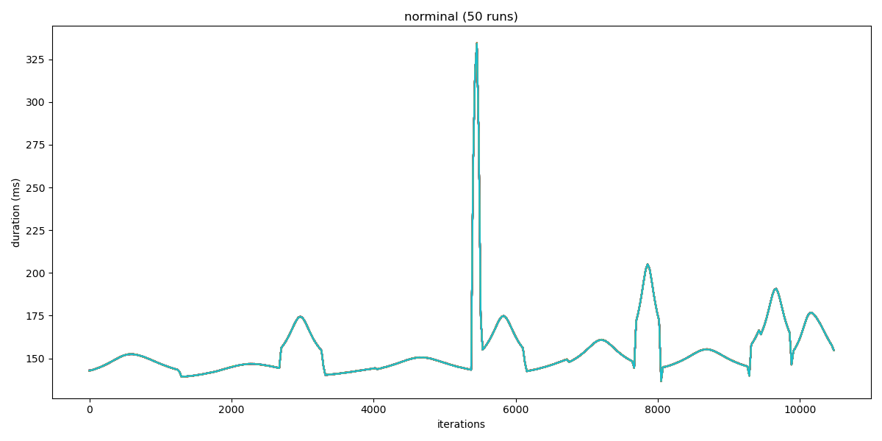

Figure 11 Preliminary visualisation of collected timing results

### Further changes for shifting to the final iMx8 target board from I&M

The TRT software was ported to I&M target iMx8 board to replace the Raspberry Pi proxy. While both are Linux-based systems, the driver porting can present a challenge as kernel sources are required. I&M provided the board Linux OS to TRT to allow the local compilation process of the critical application and of METrICS directly on the board. This smooth process enabled the incorporation of the FMS application and METrICS on the final target board with negligible alterations. The only adaptations are related to guaranteeing the real-time behaviour of the FMS application, as presented in Section 2.1.1. The porting of METrICS required no changes at all (including the driver).

## Tailoring of the THErM power measurement interface

Beyond capturing the performance of embedded dependable systems in terms of timing and resource usage, it is also critical to measure the voltage, temperature, current and power consumption of the systems, especially for heterogeneous systems embedding AI accelerators.

Power consumption is especially critical for autonomous systems, and if the learning part of the machine learning system is allowed a vast amount of resource during the training, the inference part that is embedded in the operational system have a constrained power and temperature budget.

The purpose of the THErM (Temperature Health & Energy Monitoring) power measurement interface is to gather power, voltage and temperature information from both the dependable cores running the critical software and also from the non-dependable parts running the inference algorithms as well as the measurement infrastructure.

In dependable systems, the temperature can also be a vector of attack for the system: for instance, a mischievous application can heat up the platform causing DVFS of DTM to be triggered. That may impact a dependable application, getting it a lower service due to the voltage and frequency scaling causing it to miss its real-time requirements. This violates the certification requirement of isolation between dependable systems and therefore, the effects of such thermal interference must be mitigated to ensure temperature integrity.

### Probing power and temperature on the iMx8 board

When it comes to measuring **current**, **power** or **temperature** with hardware probes, however, every manufacturer has its own implementation approach, and portability can hardly be ensured. As a consequence, the THErM interface has been specially tailored for the target hardware architecture presented below:

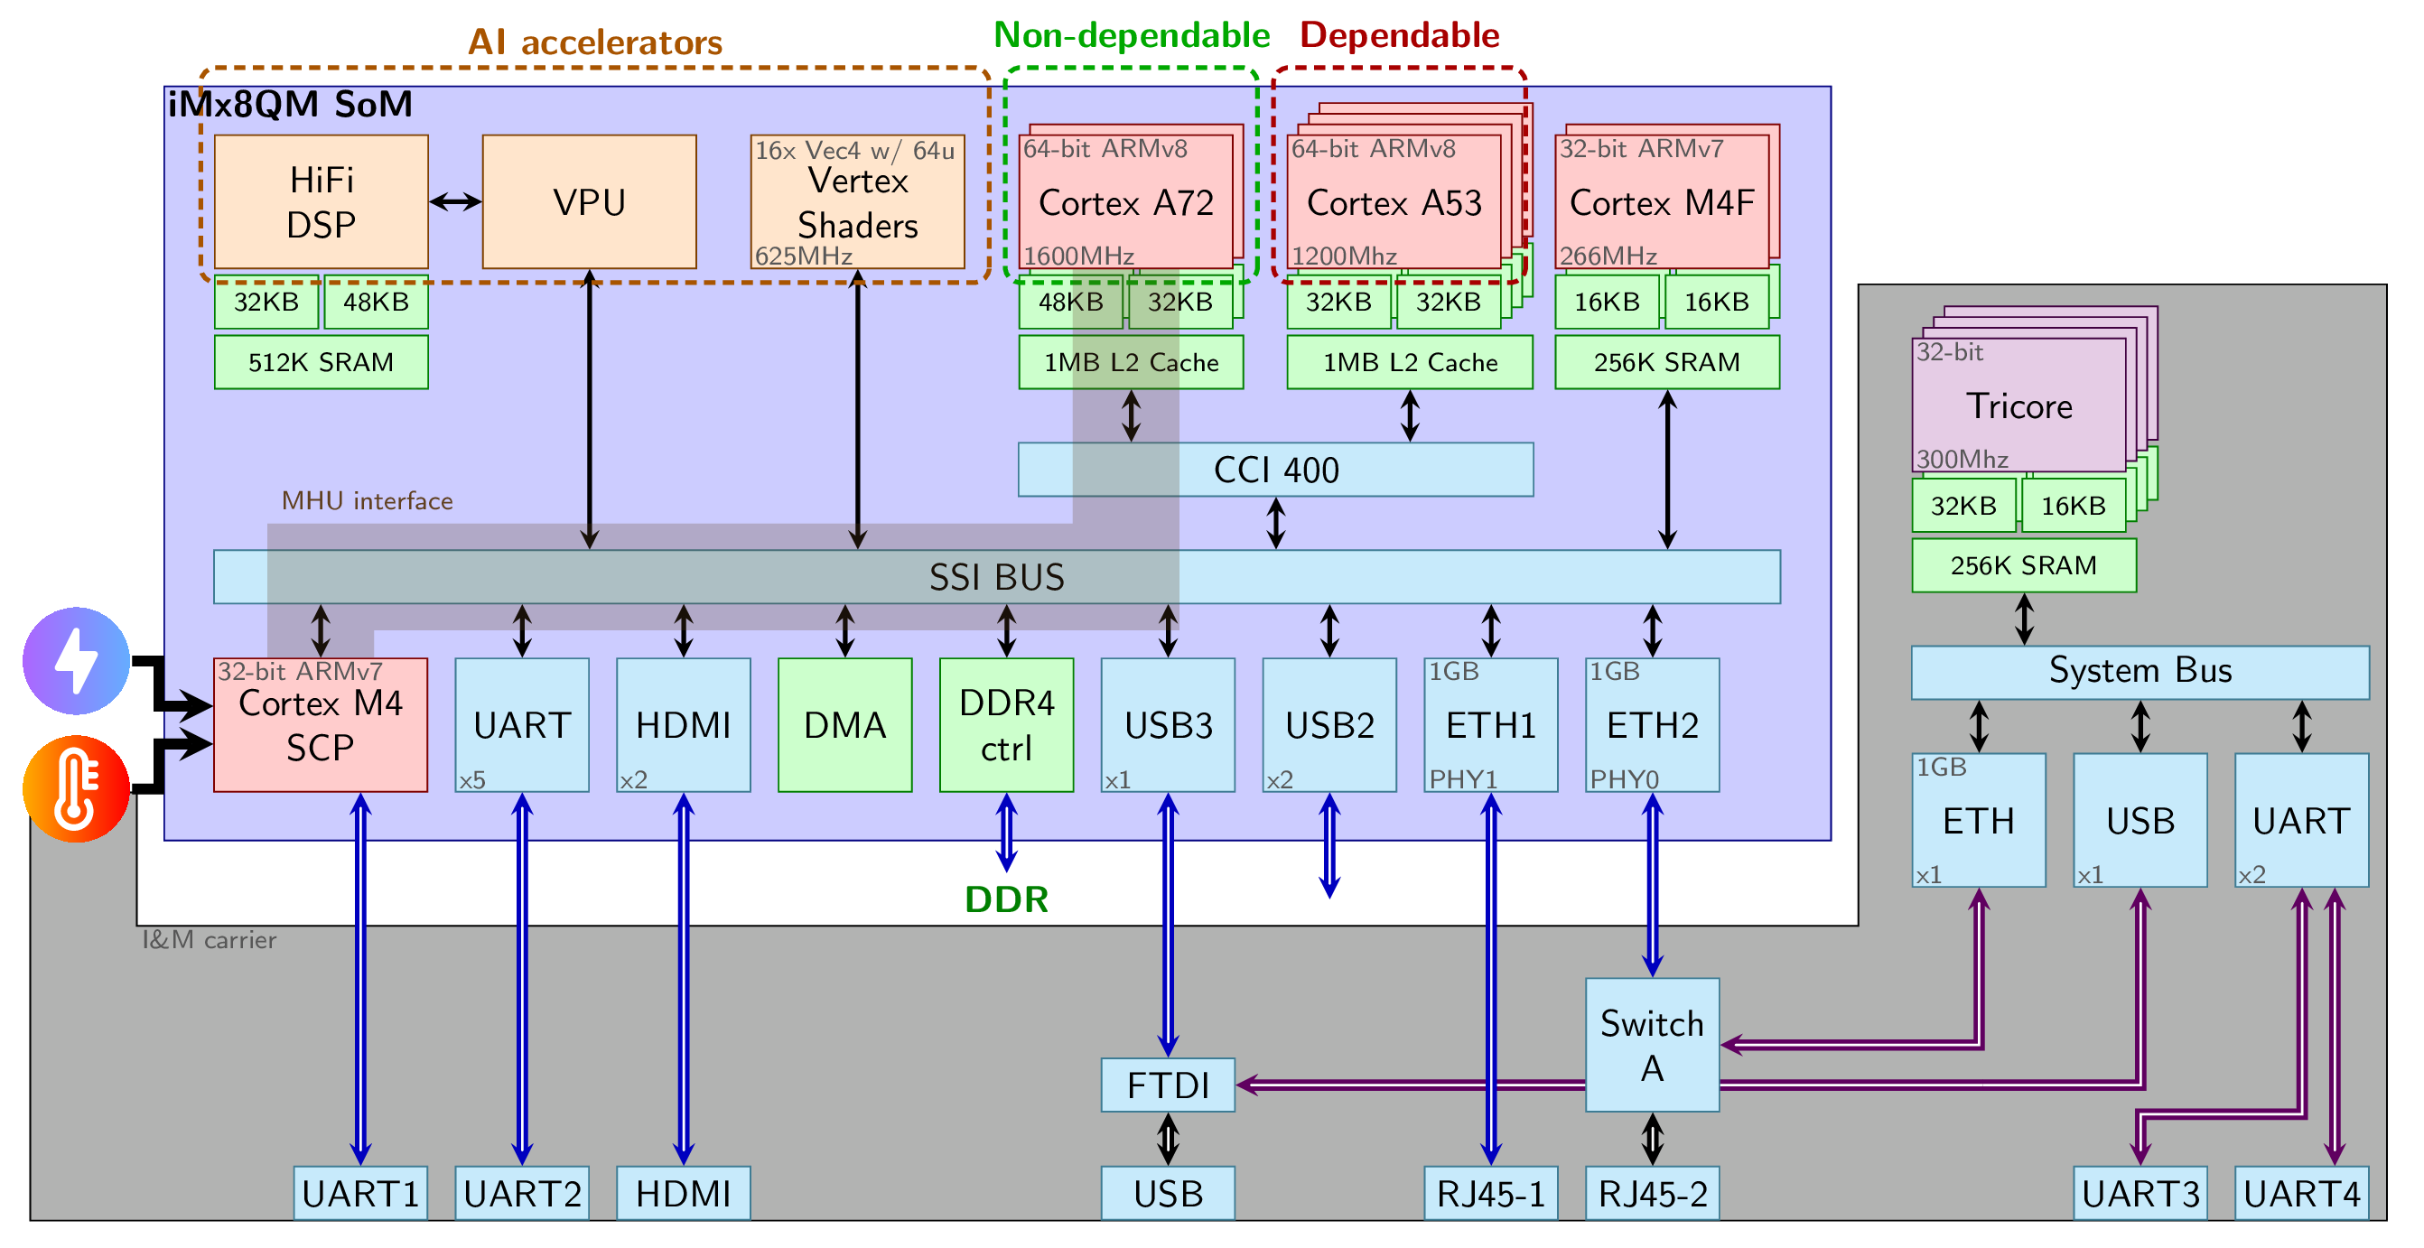

Figure 12 iMx8 socket-on-module

Figure 12 represents the iMx8 board provided by I&M. Beyond the dependable multi-core cluster of 4 Cortex ARM A53 computation cores and the non-dependable multi-core cluster of 2 Cortex A72 high-performance computation cores, the iMx8 socket-on-module embeds some additional processors, not directly programmable by the user: The System Control Processor (SCP) that is part of the SoC.

Unfortunately, as it is not possible to directly access power and temperature information from the computation cores, one must utilise not-directly programmable extra SCP core to access power, voltage and temperature information. During the iMx8 board boot sequence, the SCP core is powered first. The SCP processor is then in charge of pursuing the boot process at SoC-level and starting the applicative cores. Therefore, the power usage of the applicative cores is controlled by the SCP core.

### SoC System Control Processor (SCP)

The System Control Processor controls Socket-on-Module’s System on Chip. In addition to configuration and booting, the SCP is also in charge of power-related features (e.g. DVFS and DTM). Thus, the SCP has access to a wide scope of power and temperature-related probes. However, as it is not programmable, retrieving its data from the applicative cores (A72 and A53) demands passing through the Message Handling Unit (MHU) using its proprietary communication protocol, which is specified by ARM [7]. It encompasses the concepts of both physical and virtual channels, that together support data transfer and request signalling for the messaging interfaces. The system relies on unidirectional memory-mapped channels, each composed of three registers (STAT, SET & CLEAR) as well as an interrupt line to the receiver. The communication data flow passes through another set of dedicated memory-mapped buffers.

Therefore, the TEACHING implementation of this protocol is alike the THErM power measurement interface on the Yocto Linux running on the iMx8 board as part of the TEACHING demonstrators. All the associated uncachable physically mapped memory regions are defined and the results of the execution of an example application with these alternative features in the on state are:

Starting PowerTemp  
 - Getting access to MHU (Interface) memory regions  
 - Physical address: 2e000000  
 - Mapping MHU interface memory region to local address space  
 - addresses: scp_to_ap=0x503fb200 ap_to_scp=0x503fb300  
 - Getting access to MHU (Registers) memory regions  
 - Physical address: 2b1f0000  
 - Mapping MHU registers memory region to local address space  
 - Virtual address: 503fc000  
Probing SCP/MHU power information  
SCP monitors:  
 A72: 0.073000 A 0.905000 V 0.004239 W 29.173000 °C  
 A53: 0.126000 A 0.907000 V 0.000124 W 29.616000 °C  
 SYS: 0.898000 A 0.904000 V 0.000839 W 29.111000 °C  
 GPU: 0.060000 A 0.912000 V 0.006438 W 28.505000 °C  
SCP monitors:  
 A72: 0.073000 A 0.904000 V 0.004193 W 29.000000 °C  
 A53: 0.122000 A 0.907000 V 0.001209 W 29.383000 °C  
 SYS: 0.809000 A 0.903000 V 0.003388 W 29.107000 °C  
 GPU: 0.060000 A 0.912000 V 0.006438 W 28.501000 °C  
SCP monitors:  
 A72: 0.073000 A 0.905000 V 0.004239 W 28.770000 °C  
 A53: 0.122000 A 0.907000 V 0.001209 W 29.598000 °C  
 SYS: 0.808000 A 0.903000 V 0.002811 W 29.177000 °C  
 GPU: 0.060000 A 0.912000 V 0.004041 W 28.634000 °C

The above trace shows three successive collections of the power information, for the different parts of the ARM-v8 architecture: A72 correspond to the values related to the non-dependable high-performance 2-core cluster, A53 to the values related to the dependable low-power 4-core cluster, GPU to the Mali graphical unit, and SYS to the socket-on-module. The columns correspond respectively to the current in Ampere, the voltage in Volt, the power in Watt and the temperature in degrees Celcius. The temperature is provided with a 3-digit precision (millidegree), which should be sufficient to observe temperature variation for temperature covert attacks.

### Integration into the Cyber-Blackbox

Both METrICS and the THErM interface are providing monitoring information at a different level. The Cyber-Blackbox aims at exploiting and correlating such monitoring information through machine learning techniques to learn normal expected behaviour and detect potential threats as deviation from this learnt behaviour.

Considering the power consumption and temperature measurement, TEACHING anticipates being able to identify potential covert side-channels and detect the effect tied to wear out, once it is integrated as part of the Cyber-BlackBox.

## Driving Simulator Integration - RT HW Platform

To achieve the goal of enabling human-driven adaptive applications in CPSoS, the driving automation use case integrates TEACHING technology components into the existing driving simulator environment with the use case requirements in mind (D1.1). The centre stage of the integration activities at this interim stage of the project is the I&M’s real-time Linux-based platform, which can execute control algorithms in the automotive environment. The aim is to use the base configuration from the platform and tailor it for this specific application, the framework of which should be based on open-source tools. Another crucial function of the platform is interfacing and enabling flawless communication between various components.

The yielded functionality is tested, optimised and demonstrated using AVL’s EECACC, which is used in place of the DMU. This software control package is not the focus of TEACHING development; it is only used to aid the integration and implementation of the project’s assets into the controlled driving environment. Its implementation is performed in Matlab/Simulink. Once it is ported to the target platform, it is tested via a back-to-back test, as depicted later in Figure 16.

The common functionality of the EECACC is to gather data on vehicle external environment and subsequently conclude the demand speed per the commanded driving aggressiveness and fuel consumption, as depicted in Figure 13. Subject to the selected scenario, specific features of the EECACC can be given higher weighting and priority e.g. driving aggressiveness loses importance in an urban environment with plentiful traffic lights. This functionality is exploited by applying a selected driving mode for the automated vehicle (e.g. normal mode versus sporty or aggressive driving style). The driving mode results from the estimation of the human state based on the sensor data. This functionality is exploited in the driving simulator study (section 4.4) to create appropriate conditions for enticing suitable responses from the study participants. The aim is to gather relevant user perception data so that it can be used for modelling human behaviour and later integration into the sensing and vehicle control in driving automation scenarios.

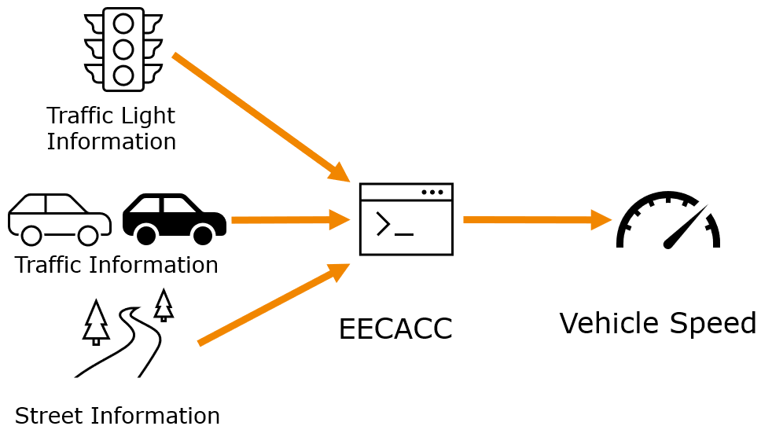

Figure 13 EECACC input - output variables

The EECACC is integrated with other SW components into the I&M’s (SDF) RT Linux-based platform. The intention is to simplify this integration process, some of which relies on tools developed with the TEACHING project in mind [8]. Beyond the design and integration phases, the intention is to maintain ease of firmware updates Over-The-Air (OTA) and to improve the HW abstraction with this high-performance ECU.

The high-level platform block diagram is shown in Figure 14. It is reliant on the development of Robot Operating System (ROS) nodes. ROS is an open-source middleware that allows the partitioning of a complex system into small and reusable blocks called nodes. The communication among these nodes is based on the publish/subscribe paradigm. The nodes can be either all on the same physical device or distributed among many. Shipping ROS to the board is achieved by deploying the meta-ROS layer into the Yocto project and including it in the deployment image. That is followed by adjustment of the included components to keep the footprint as small as possible. Deployment of the custom ROS node to the board relies on building Yocto customisation and usage of ament_cmake. Yocto’s devtool command is used to create a recipe in the workspace that is then included for subsequent builds of the deployment image.

The EECACC is wrapped into the ROS2 node (cacc_node) together with the CAN input node (can_parser). The CAN node accesses the CAN bus and translates its messages into ROS messages. In particular, it bridges the CACC and the simulated sensors and actuators. The output actuation signals are passed towards the driving simulator via output CAN and Ethernet nodes. This ROS2 platform is integrated into the RT Linux kernel, which forms the SW basis of the HW platform.

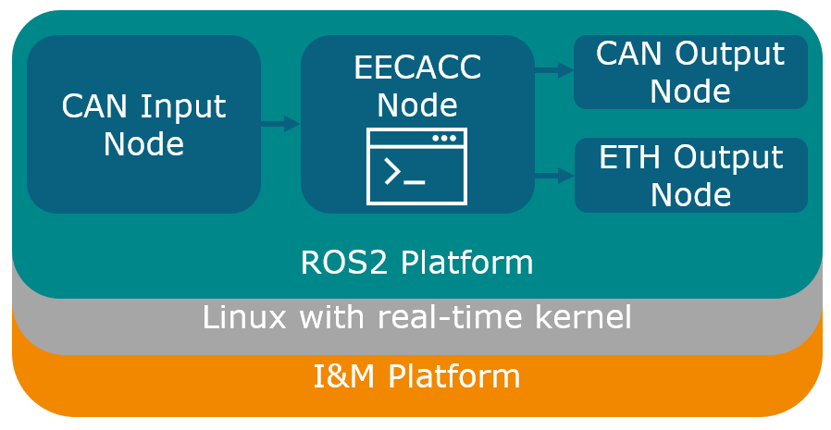

Figure 14 I&M ECU platform for integration into the driving simulator

Finally, the mqtt_bridge node listens for messages coming from the human state recognition (Figure 15) and driving style personalisation application (developed in WP4), that runs on a separate board. The node receives the output of the driving style choice and sends it to the cacc_node. The two boards communicate over Ethernet. The ROS2 nodes can be tweaked to have better timing determinism, by avoiding dynamic memory allocation at runtime and setting CPU affinity, which will be considered soon within the project.

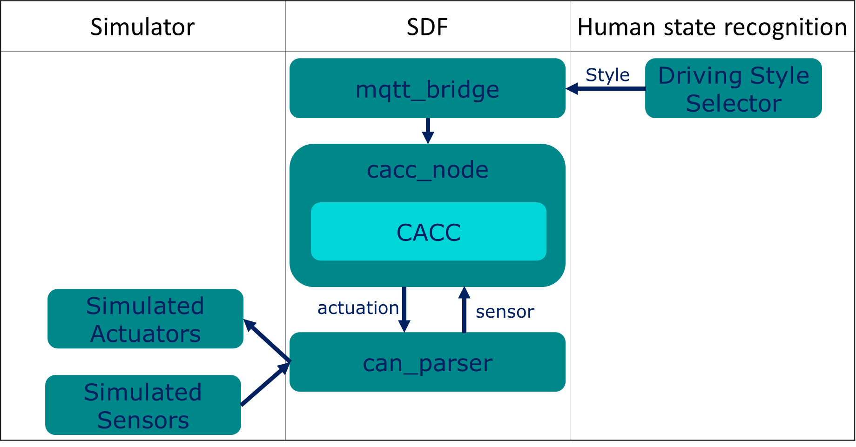

Figure 15 Automotive Use Case partitioning

The depiction of the ECU’s verification is provided in Figure 16. The SW is tested in Model-In-the-Loop (MIL) environment and references are prepared for the Hardware-In-the-Loop (HIL) testing for back2back evaluation. That step was followed by testing of interfaces and resources of the integrated SW on the target platform. These activities are supported by the development of the co-simulation model in AVL’s Model.ConnectTM environment. Upon performing the HIL tests, the comparison of the MIL and HIL results is possible.

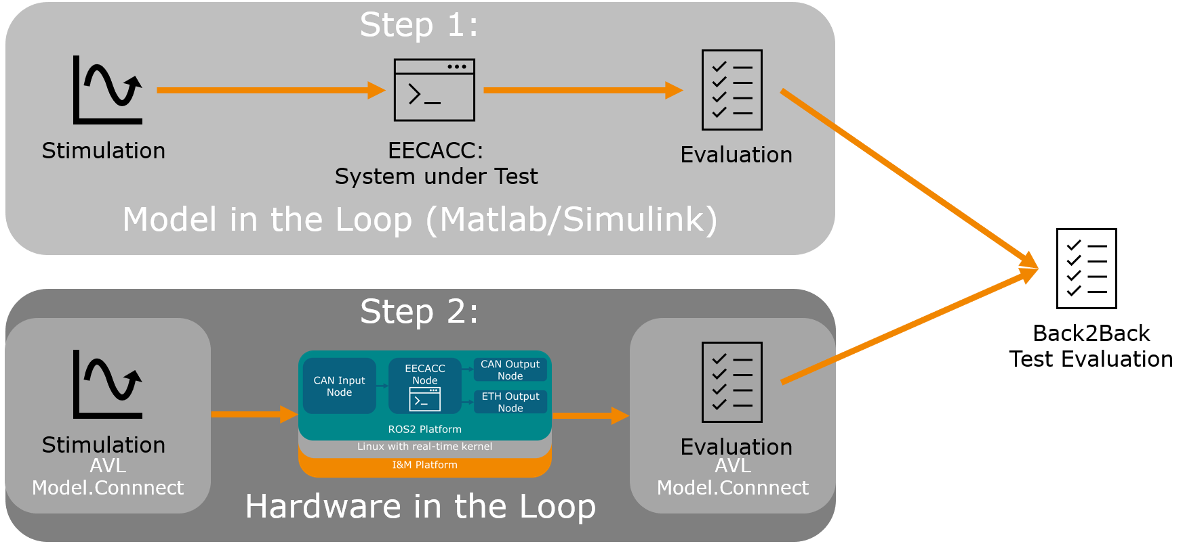

Figure 16 ECU platform integration verification

The initial results (Figure 17) demonstrate a good match of the reference vehicle acceleration from the test case (green signal) and the demand vehicle acceleration (red signal) from EECACC, which is integrated into the I&M’s ECU. Upon completion of the initial back2back tests, current activities are focusing on proof that all real-time requirements are fulfilled. The following steps are focused on further extensions of the system, which are to be detailed in D5.4 towards the end of the TEACHING project.

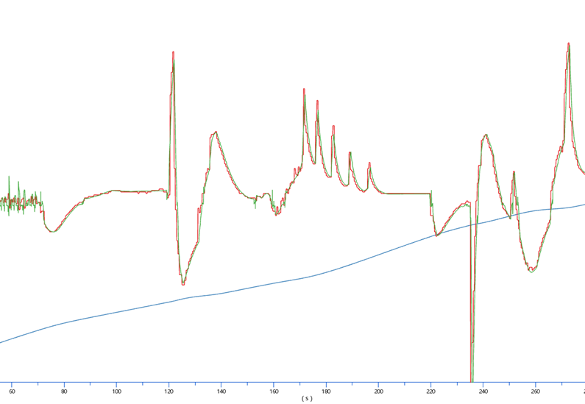

Figure 17 ECU back2back initial test results

## Automotive Study Design

An automotive use case development relies on the collection of realistic data and modelling of the human perception based on this data. That data could be further enhanced for improvement of the models or the measurements could be repeated for validation and verification of the created model. The stages of this process are drawn in Figure 18.

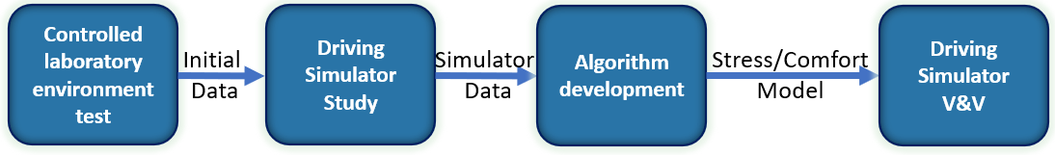

Figure 18 Driving Automation Study Stages

The initial controlled laboratory test is a result of mitigation measures taken as a result of the Covid-19 pandemic. The original plan was for this stage to be performed at a driving simulator. Due to the physical restrictions to access the simulator, this data collection was performed in a controlled environment with no driving simulator. The individuals are subjected to an increase of cognitive load (chess puzzles of Figure 19) while their psychophysiological data is recorded. The purpose of this stage is to data of the right type and format as a preparatory phase for the real driving simulator study of stage 2.

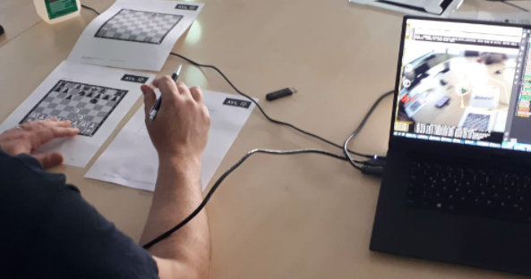

Figure 19 Initial COntrolled Testing - Increased Cognitive Load

The purpose of the second stage (Driving Simulator) is to measure human comfort and stress. The common benefit of driving simulators is increased AD profile amongst the end-users and general population. The commonly expressed criticism of driving simulation and its differences from the real driving is justified by the need for test repeatability (e.g. weather conditions, traffic flow, etc.) and the safety of the participants. They work towards increasing user acceptance by determining the trust in AD functions and improvements of trust through experience while eliminating the need for complete vehicle prototypes [9]. The data collected from the study is to be exploited for the creation of appropriate models. The measurements focus on:

* Subjective estimation of the human state through subjective questionnaires
* Objective quantification of the human state through measurement of psychophysiological signals (e.g. HR, HRV, GSR etc.)

To get to this state, the initial work considers appropriate definitions of human perception (e.g. comfort, stress and overall satisfaction of the system). These definitions help outline the scales for each one of those perception aspects, which are independent of each other. To entice the right response from the subjects on the driving simulator, a set of TEACHING specific scenarios is used for the driving simulation. A simplified example of scenario building is shown in Figure 20. The scenarios are specifically designed to entice the appropriate responses from the subjects in the simulator, but also to aid the achievement of the originally proposed use case application (motorway platooning). A detailed description of the scenario setup and potential scenario integration is described in D5.1 and by Clement et al in [10].

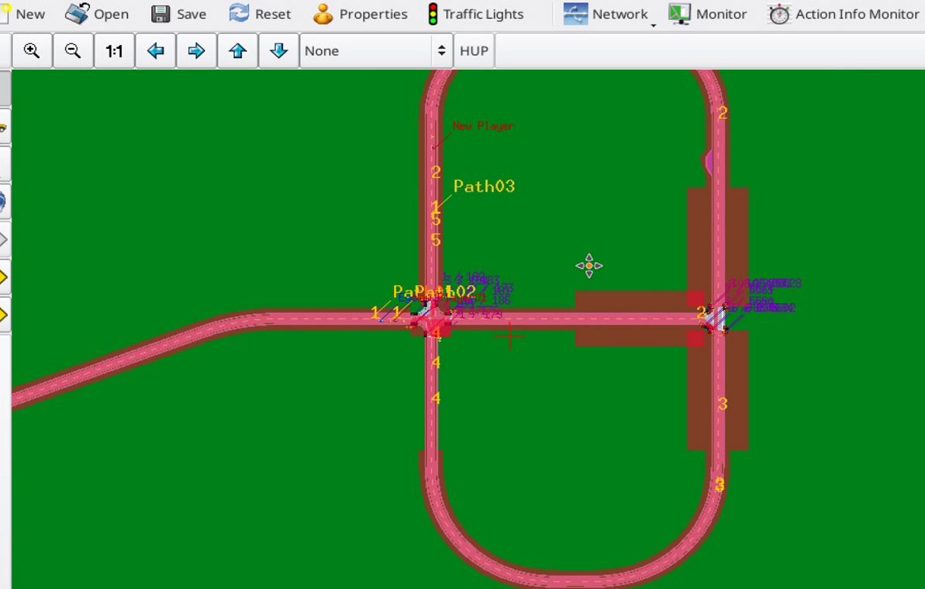

Figure 20 Creation of the Driving Environment for the Driving Scenario Building

A set of 3 driving scenarios, each with a dual usage is planned for the study. With the preparatory scenario, which is used to enable participant acclimatisation to the driving simulator, a total of 7 scenarios is implemented, as listed in Table 3. The first two scenarios are relying on the EECACC controlling the vehicle in a situation where an overtaking vehicle cuts in front of the ego vehicle in a manner that could potentially be seen as unsafe by many drivers in real driving (as depicted in Figure 21). The ego vehicle reaction is determined by the selected driving style, which is passed to the EECACC, as depicted in Figure 15. The scenario is executed twice, once in a sporty driving mode and the second time in comfort driving mode. The scenario is designed so to entice an appropriate level of reaction from the study participants (objective and subjective).

Figure 21 The cut-in scenario

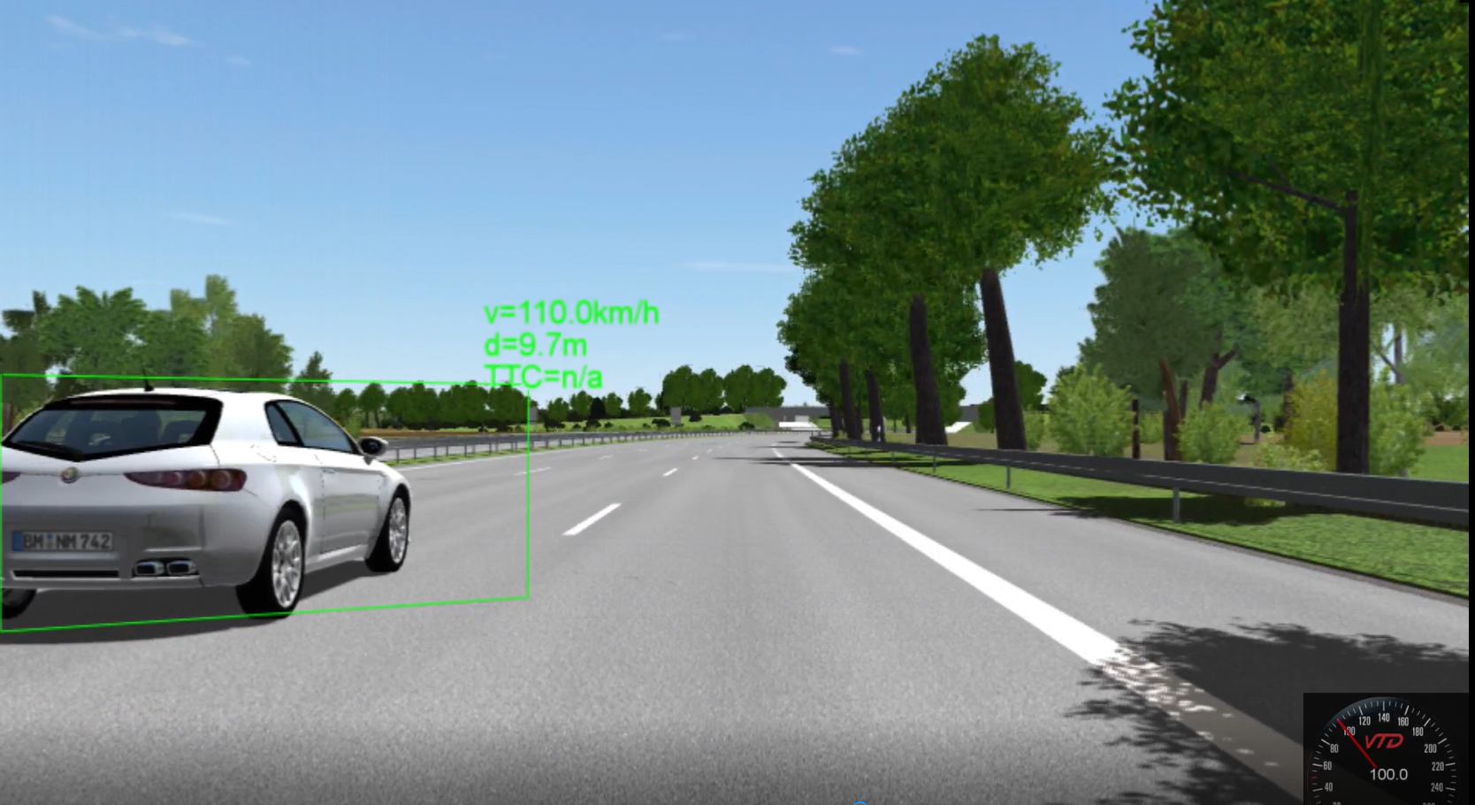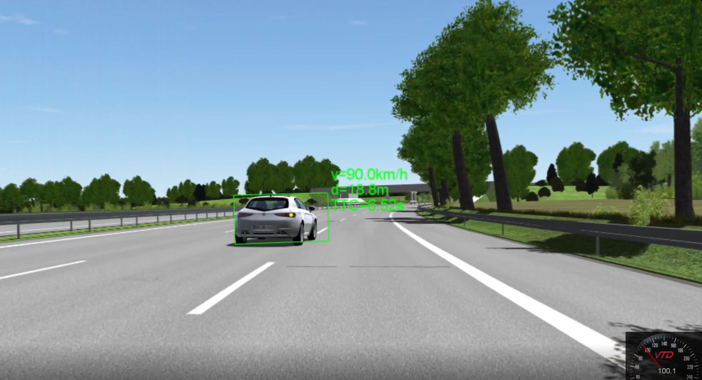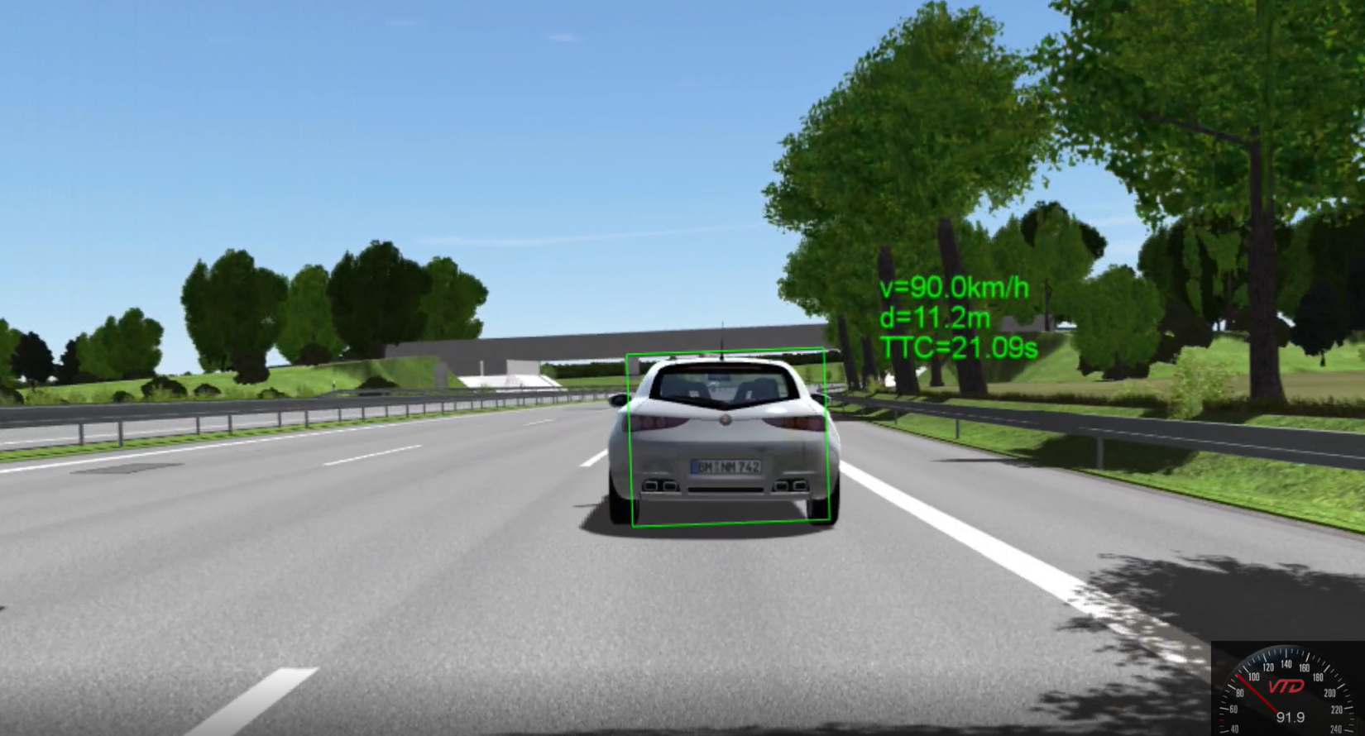

The following two scenarios are executed in a platooning convoy. The ego vehicle enters a motorway and joins the platooning convoy at a speed. As the ego vehicle settles its own speed and becomes the last member in the platoon, the vehicle in front of it, breaks out of the platoon and the ego vehicle speeds up again to maintain the platoon formation at the predetermined distance. The scenario is executed twice, once in fine weather conditions and the second time with poor visibility caused by the poor weather.

The last scenario pair considers a dysfunctional EECACC i.e. phantom breaking with no explainable content being displayed to the study participant. As the ego vehicle drives around a slight bend in an urban environment, the ego vehicle’s sensors detect a somewhat inappropriately parked loading vehicle at the side of the road. As the ego vehicle detects the situation as potentially dangerous, it executes phantom braking while being in the sporty driving mode. Upon the braking action, the vehicle returns to the same driving mode in the first instance. In the second instance, the scenario is replayed, but with the driving mode being degraded to comfortable immediately upon the phantom braking. All driving scenarios are designed to maximise the human reaction while maintaining the believability of the driving situations. All the scenarios are executed in Level 5 SAE mode. The planned number of study participants is 55.

Table 3 Automotive use case scenario list

|  |  |  |  |
| --- | --- | --- | --- |
| **#** | **LVL 5 - scenarios** | **Driving Mode (DM)** | **DM adaptation** |
| 0 | 7 mins free automated driving | N/A | N/A |
| 1 | CACC with cut in (an overtaking vehicle cuts in front of the ego vehicle) | sport | N/A |
| 2 | comfort | N/A |
| 3 | Merging into the platooning convoy at the motorway | comfort (good weather cut out) | N/A |
| 4 | comfort (bad weather cut out) | N/A |
| 5 | CACC dysfunctional - phantom breaking due to the vehicle (truck) parked on the side of the road at the curve | N/A | returning to the same DM after the phantom breaking |
| 6 | N/A | lowering the DM after the phantom breaking |

The study data is to focus on the measurement of human comfort and discomfort from the perspective of the automotive domain. In that sense, the two are treated as independent constructs, so that the absence of discomfort does not automatically imply a state of comfort. Upon each scenario (of Table 3), a set of questions is presented to the participants in association with the relevant pool of parameters needed to establish human perception models. On the other hand, the data is to be analysed to determine user acceptance, which is an important condition for the successful implementation of AD vehicles [11]. The objective data is collected using the set of wearable sensors described for physiological data processing (primarily HR and HRV measurement), as described in section 3.2.9 of D5.1.

The data collected from the driving simulation study is to be fed into WP4 for further development of the human perception models. That process forms the third stage of the process depicted in Figure 18. Once the WP4 contributors are satisfied with their modelling results and would like to validate the output of the WP, the driving simulation will be further enhanced for validation and verification of the generated model. That, the fourth, stage of the process will also offer an opportunity for optimisation of the generated model. At the same time, the period used for the development of the human model is to be utilised for the improvement of the TEACHING HW and SW components as well as for their integration into the driving simulator.

# Conclusion

The deliverable focuses on the evaluation of the computing, adaptation and dependability functionalities of the CPSoS on safety-critical industrial applications through avionics and autonomous driving (AD) demonstration environments. The two selected industrial domains are targeted for the initial development and optimisation of the TEACHING technology bricks. Simultaneously, TEACHING partners aim to enable the easy portability of the offered solutions.

The described work is focusing on results and plans for future work at the interim stage of the project. The avionics use case considers safety and security-critical applications based on the implementation of the Flight Management System (FMS), the HIDS/HUMS monitoring system and the Cyber-Black-Box (CBB). The real-time requirements of the proposed application can be satisfied by the developed TEACHING specific Linux-based HW platform. Crucially, the SW algorithms are easily portable between different HW platforms with minimal to no need for alterations to satisfy the current application. The workaround for the AI algorithms is focused on converging with hardware capabilities to allow software components to learn common behaviour and hence detect safety/security induced deviations as anomalies with regards to this expected behaviour. This work is to be continued to further optimise the existing SW components and their integration into the newly developed HW component.

The automotive use case is based on a premise that is similar to that of avionics. The difference is that this time, the human is no longer the key decision-maker in the CPSoS, but is also the source of quantifiable information that is used for objectified controlling of the highly automated dependable system. It is this quantification that is in the focus of the current activities, primarily, the driving simulator study which targets the creation of new TEACHING specific data for improvement of the human perception models. Once adequately established, these models are potential game-changers in terms of driving automation, which needs to be based on responding to the needs of the users in real-time.

Both use cases are to be used for supporting further evolution of the TEACHING technology bricks through optimisation of the offered components in a prospective (but for now controlled) industrial environment.

# References

|  |  |
| --- | --- |
| [1] | D. Bacciu, S. Akarmazyan, E. Armengaud, M. Bacco, G. Bravos, C. Calandra, E. Carlini, A. Carta, P. Cassarà, M. Coppola, C. Davalas, P. Dazzi and O. Veledar, “TEACHING - Trustworthy autonomous cyber-physical applications through human-centred intelligence,” in *2021 IEEE International Conference on Omni-Layer Intelligent Systems (COINS)*, Barcelona, 2021. |
| [2] | N. Wikström, A. F. Parrilla, S. J. Jones and A. Grauers, “Energy-Efficient Cooperative Adaptive Cruise Control with Receding Horizon of Traffic, Route Topology, and Traffic Light Information,” in *SAE Intl. J CAV 2(2)*, 2019. |
| [3] | G. Macher, S. Akarmazyan, E. Armengaud, D. Bacciu, C. Calandra, H. Danzinger, P. Dazzi, C. Davalas, M. C. De Gennaro, A. Dimitriou, J. Dobaj, M. Dzambic, L. Giraudi, S. Girbal, D. Michail, R. Peroglio, R. Potenza, F. Pourdanesh, M. Seidl, C. Sardianos, K. Tserpes, J. Valtl, I. Varlamis and O. Veledar, “Dependable Integration Concepts for Human-Centric AI-based Systems,” in *SAFECOMP 2021. Lecture Notes in Computer Science*, Cham, 2021. |
| [4] | R. Graubohm, T. Stolte, G. Bagschik, M. Steimle and M. Maurer, “Functional Safety Concept Generation within the Process of Preliminary Design of Automated Driving Functions at the Example of an Unmanned Protective Vehicle,” in *Proceedings of the Design Society: International Conference on Engineering Design*, 2019. |
| [5] | P. Malhotra, A. Ramakrishnan, G. Anand, L. Vig, P. Agarwal and G. Shroff, “LSTM-based Encoder-Decoder for Multi-sensor Anomaly Detection,” *arXiv e-prints,* p. arXiv:1607.00148, 2016. |
| [6] | G. Pang, C. Shen, L. Cao and A. van den Hengel , “Deep Learning for Anomaly Detection: A Review,” *arXiv e-prints,* p. arXiv:2007.02500, 2020. |
| [7] | ARM Compute Subsystem SCP, Version: 1.1, Message Interface Protocols, ARM Limited, August 2016. |
| [8] | M. Dzambic, C. Kreuzberger, O. Veledar and G. Macher, “A Rapid Prototyping System, Intelligent Watchdog and Gateway Tool for Automotive Applications,” in *2021 IEEE 18th International Conference on Software Architecture Companion (ICSA-C)*, 2021. |
| [9] | G. Hanzl, M. Haberl, A. Eichberger and M. Fellendorf, “Driver’s Acceptance of Automated Driving Systems Based on a Driving Simulator Study,” *International Forum on Advanced Microsystems for Automotive Applications,* pp. 186-195, 2020. |
| [10] | P. Clement, H. Danzinger, O. Veledar, C. Koenczoel, G. Macher and A. Eichberger, “Measuring trust in automated driving using amulti-level approach to human factors,” in *In Print (Euromicro DSD/SEAA Conference 2021)*, Palermo, 2021. |
| [11] | S. Nordhoff, B. Van Arem and R. Happee, “Conceptual model to explain, predict, and improve user acceptance of driverless podlike,” *Transportation research record,* no. 2602, pp. 60-67, 2016. |

1. † *The research leading to these results has received funding from the European Union’s Horizon 2020 research and innovation programme under grant agreement No 871385.*
2. Due to the size of the archive and the limitations to the access of the partners network, the code can be made available to the reviewers upon request.